ME 2

AIG AUDIT 2

Vocabulary 2

Inshoring SOX functions 2

RPA 2

SOX Controls 2

AUDIT SKILLS 2

IIA standards 2

Standard 1210 – Proficiency 2

Standard 2010 – Planning 2

Standard 2030 – Resource Management 2

Standard 2100 – Nature of Work 2

Standard 2110 – Governance 2

Standard 2130 – Control 3

Standard 2200 – Engagement Planning 3

Standard 2201 – Planning Considerations 3

Standard 2210 – Engagement Objectives 3

Standard 2220 – Engagement Scope 3

Standard 2230 – Engagement Resource Allocation 3

Standard 2240 – Engagement Work Program 3

Standard 2310 – Identifying Information 3

Audit Metrics 3

Frequency 3

Environment 3

Output 3

Quality 3

Efficiency 3

Impact 3

Audit Acquisitions 3

Life Cycle 3

Strategy 3

Due Diligence 4

Deal Approval and Close 4

Integration 4

Audit Agile Projects 4

Audit AI 4

Audit Big Data 5

Stakeholders 5

Risk and Control 5

Audit Cloud 5

Security Controls 5

Auditing SAAS 5

Context 6

Risks 6

Service Layer 6

IT Functions 6

Incident Management 6

Audit Cyber Security 6

Three Lines of Defence 6

Audit DEVOPS-CI/CD 7

CircleCI 7

TECHNOLOGY 7

AWS 7

HADOOPP 9

STREAM 9

SPARK 10

Core 10

SQL 10

Streaming 10

Mlib Machine Learning Library 10

GraphX 10

APACHE KAFKA 10

DJANGO 11

SQL 11

Oracle PL/SQL 11

T-SQL 12

INNER JOIN 13

LEFT OUTER JOIN 13

FULL OUTER JOIN 13

CARTESIAN PRODUCT 13

LATERAL JOIN (CROSS APPLY) 13

UNION ALL 13

UNION 13

INTERSECT 13

EXCEPT 13

PIVOT 14

OVER() 14

SQL CLR 15

TABLEAU 15

Workbook Components 15

Tableau Interface 16

POWER BI 16

MONGODB 16

Microservices 17

API 17

12 FACTORS 17

REST 18

DOCKER 18

KUBERNETES 18

PYTHON 19

LUIGI 19

DASK 19

PANDAS 19

SQL ALCHEMY 19

R 19

Data Structure 19

JAVASCRIPT 19

SCIKIT-LEARN 19

TENSORFLOW 19

PYTORCH 19

MACHINE LEARNING 19

Regression 19

Boost 19

Deep Learning 19

Feature Engineering 19

EXHIBIT 20

SOX Application Inventory 20

Audit Lifecycle 38

AGILE AUDIT 38

APPLICATION DEVELOPMENT AGILE 40

NOVA Target State 41

IDR Data Governance 42

IDR Data Quality Lifecycle 42

IDR State Architecture 44

NON-CLEARWATER 46

CLEARWATER 49

# ME

203 726-1711

TN-VISA (2015-08-27)

I-140, H1-B (2017-10-17 to 2020-09-06)

⬩Experience in: technology consulting, system auditing, privacy, cyber-security, e-commerce, e-money licensing, digital or online advertising, cloud, online payment regulations, anti-money laundering, online media and entertainment, online content licensing royalty management, software development, supply chain systems and processes, hardware manufacturing, financial processes and systems, mergers and acquisitions, large project systems integration, risk management, or data analytics ⬩Experience with internet technology from a technical, regulatory, or commercial perspective ⬩Ability to navigate through complex systems, ambiguity, and to manage multiple project assignments ⬩Ability to interact with subject matter experts to understand how key code elements address specific risk ⬩Ability to interact confidently with all levels, to set objectives, and to drive results.

# AIG AUDIT

## Vocabulary

⬩**ELC** (Entity Level Control) ⬩**OSP** (Outside Service Providers) Oversight ⬩**LU**= Least (privileged) User Access ⬩**NTE**= nature, timing and extent ⬩**SSAE16 SOC1, SOC2** ⬩**Audit Writing 5C’s**: Criteria (what should be), Condition (the current state), Cause (the reason for the difference), Consequence (effect), Corrective action plans/recommendations.

## Inshoring SOX functions



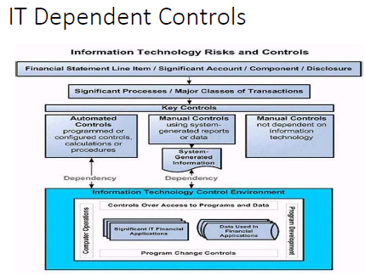



## RPA

⬩Initiated from Accounts Payable (NJ), DBA <Tax, FIS Billing, FP&A Planning&Analysis, Comptrollers> ⬩Consultant: GENPACT ⬩Process 1: Batch creation + Monies moving ⬩Process 2: VOID/STOP Payment (Reversal) ⬩Systems AWD (Automated Work Distributor Imaging & Workflow), OASYS PrC (Fixed annuity Admin) ⬩ RPA: OPENSPAN PEGASYSTEMS

## SOX Controls

NON-CLEARWATER; CLEARWATER

# AUDIT SKILLS

## IIA standards

#### Standard 1210 – Proficiency

Internal auditors must possess the knowledge, skills, and other competencies needed to perform their individual responsibilities. The internal audit activity collectively must possess or obtain the knowledge, skills, and other competencies needed to perform its responsibilities.

**Interpretation:**

*Proficiency is a collective term that refers to the knowledge, skills, and other competencies required of internal auditors to effectively carry out their professional responsibilities. It encompasses consideration of current activities, trends, and emerging issues, to enable relevant advice and recommendations. Internal auditors are encouraged to demonstrate their proficiency by obtaining appropriate professional certifications and qualifications, such as the Certified Internal Auditor designation and other designations offered by The Institute of Internal Auditors and other appropriate professional organizations.*

**1210.A3 –** Internal auditors must have sufficient knowledge of key information technology risks and controls and available technology-based audit techniques to perform their assigned work. However, not all internal auditors are expected to have the expertise of an internal auditor whose primary responsibility is information technology auditing.

#### Standard 2010 – Planning

The chief audit executive must establish a risk-based plan to determine the priorities of the internal audit activity, consistent with the organization’s goals.

**Interpretation:**

*To develop the risk-based plan, the chief audit executive consults with senior management and the board and obtains an understanding of the organization’s strategies, key business objectives, associated risks, and risk management processes. The chief audit executive must review and adjust the plan, as necessary, in response to changes in the organization’s business, risks, operations, programs, systems, and controls.*

**2010.A1 –** The internal audit activity’s plan of engagements must be based on a documented risk assessment, undertaken at least annually. The input of senior management and the board must be considered in this process.

**2010.A2** – The chief audit executive must identify and consider the expectations of senior management, the board, and other stakeholders for internal audit opinions and other conclusions.

**2010.C1 –** The chief audit executive should consider accepting proposed consulting engagements based on the engagement’s potential to improve management of risks, add value, and improve the organization’s operations. Accepted engagements must be included in the plan.

#### Standard 2030 – Resource Management

The chief audit executive must ensure that internal audit resources are appropriate, sufficient, and effectively deployed to achieve the approved plan.

**Interpretation:**

*Appropriate refers to the mix of knowledge, skills, and other competencies needed to perform the plan. Sufficient refers to the quantity of resources needed to accomplish the plan. Resources are effectively deployed when they are used in a way that optimizes the achievement of the approved plan.*

#### Standard 2100 – Nature of Work

The internal audit activity must evaluate and contribute to the improvement of the organization’s governance, risk management, and control processes using a systematic, disciplined, and risk-based approach. Internal audit credibility and value are enhanced when auditors are proactive and their evaluations offer new insights and consider future impact.

#### Standard 2110 – Governance

The internal audit activity must assess and make appropriate recommendations to improve the organization’s governance processes for:

* Making strategic and operational decisions.
* Overseeing risk management and control.
* Promoting appropriate ethics and values within the organization.
* Ensuring effective organizational performance management and accountability.
* Communicating risk and control information to appropriate areas of the organization.
* Coordinating the activities of, and communicating information among, the board, external and internal auditors, other assurance providers, and management.

**2110.A2 –** The internal audit activity must assess whether the information technology governance of the organization supports the organization’s strategies and objectives.

#### Standard 2130 – Control

The internal audit activity must assist the organization in maintaining effective controls by evaluating their effectiveness and efficiency and by promoting continuous improvement.

#### Standard 2200 – Engagement Planning

Internal auditors must develop and document a plan for each engagement, including the engagement’s objectives, scope, timing, and resource allocations. The plan must consider the organization’s strategies, objectives, and risks relevant to the engagement.

#### Standard 2201 – Planning Considerations

In planning the engagement, internal auditors must consider:

* The strategies and objectives of the activity being reviewed and the means by which the activity controls its performance.
* The significant risks to the activity’s objectives, resources, and operations and the means by which the potential impact of risk is kept to an acceptable level.
* The adequacy and effectiveness of the activity’s governance, risk management, and control processes compared to a relevant framework or model.
* The opportunities for making significant improvements to the activity’s governance, risk management, and control processes.

**2201.C1 –** Internal auditors must establish an understanding with consulting engagement clients about objectives, scope, respective responsibilities, and other client expectations. For significant engagements, this understanding must be documented.

#### Standard 2210 – Engagement Objectives

Objectives must be established for each engagement.

**2210.A1 –** Internal auditors must conduct a preliminary assessment of the risks relevant to the activity under review. Engagement objectives must reflect the results of this assessment.

**2210.A2 –** Internal auditors must consider the probability of significant errors, fraud, noncompliance, and other exposures when developing the engagement objectives.

**2210.C1 –** Consulting engagement objectives must address governance, risk management, and control processes to the extent agreed upon with the client.

**2210.C2 –** Consulting engagement objectives must be consistent with the organization's values, strategies, and objectives.

#### Standard 2220 – Engagement Scope

The established scope must be sufficient to achieve the objectives of the engagement.

**2220.A1 –** The scope of the engagement must include consideration of relevant systems, records, personnel, and physical properties, including those under the control of third parties.

#### Standard 2230 – Engagement Resource Allocation

Internal auditors must determine appropriate and sufficient resources to achieve engagement objectives based on an evaluation of the nature and complexity of each engagement, time constraints, and available resources.

**Interpretation:**

*Appropriate refers to the mix of knowledge, skills, and other competencies needed to perform the engagement. Sufficient refers to the quantity of resources needed to accomplish the engagement with due professional care.*

#### Standard 2240 – Engagement Work Program

Internal auditors must develop and document work programs that achieve the engagement objectives.

#### Standard 2310 – Identifying Information

Internal auditors must identify sufficient, reliable, relevant, and useful information to achieve the engagement objectives.

**Interpretation:**

*Sufficient information is factual, adequate, and convincing so that a prudent, informed person would reach the same conclusions as the auditor. Reliable information is the best attainable information through the use of appropriate engagement techniques. Relevant information supports engagement observations and recommendations and is consistent with the objectives for the engagement. Useful information helps the organization meet its goals.*

## Audit Metrics

#### Frequency

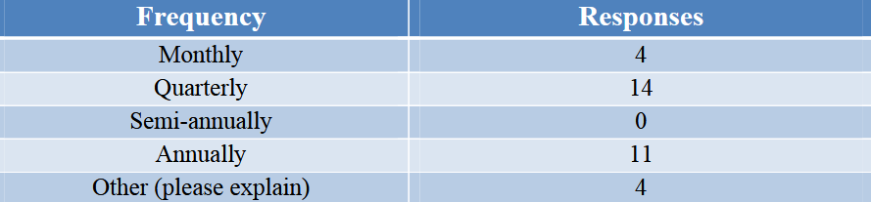

#### Environment

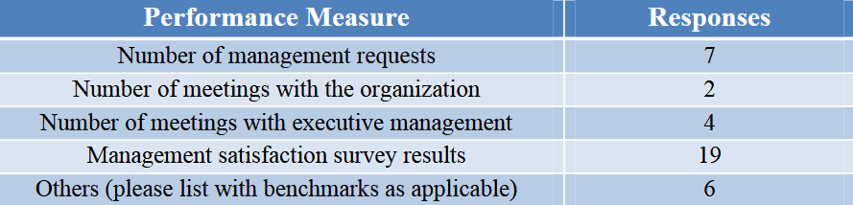

#### Output

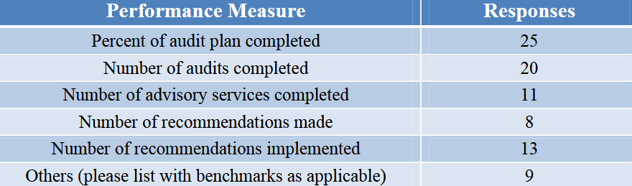

#### Quality

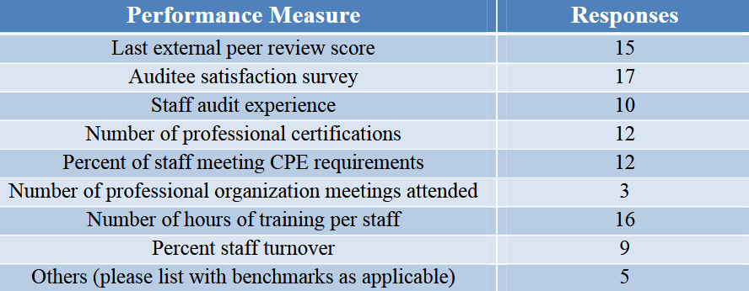

#### Efficiency

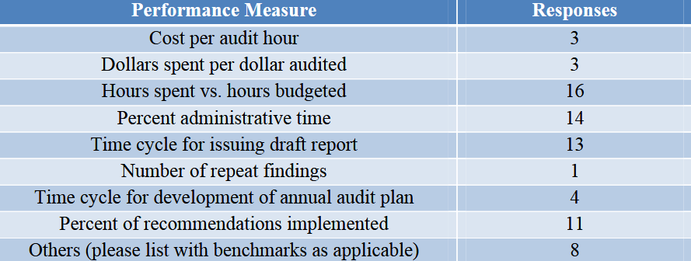

#### Impact

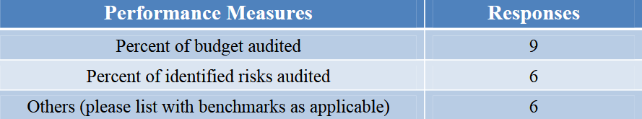

## Audit Acquisitions

#### Life Cycle

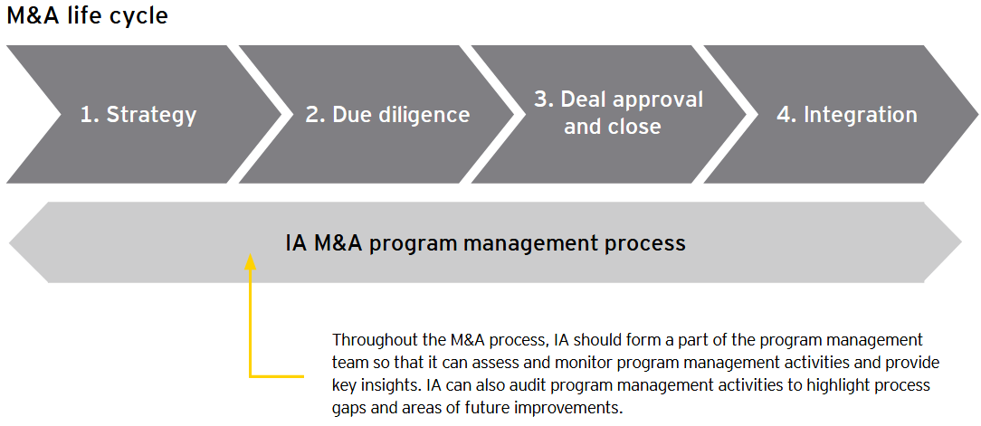

#### Strategy

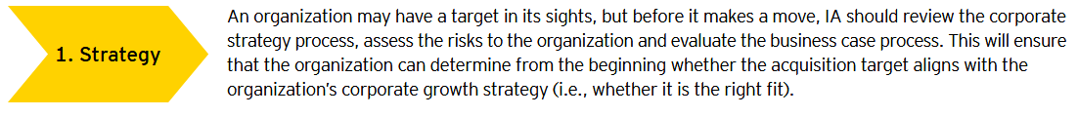

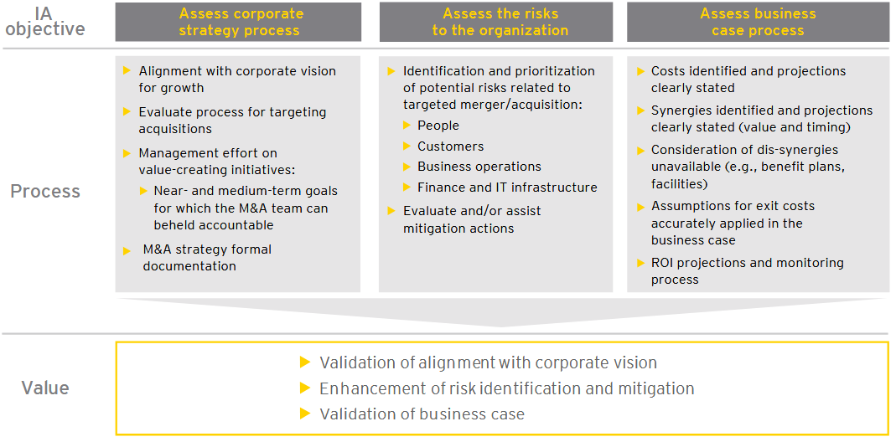

#### Due Diligence

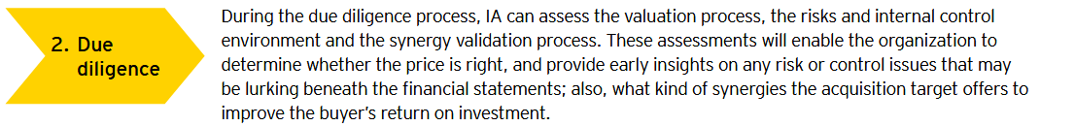

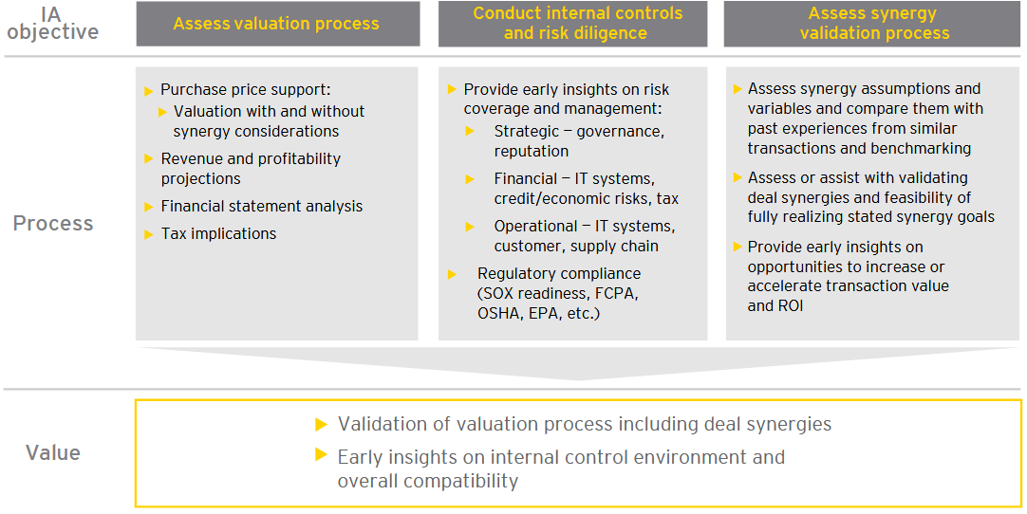

#### Deal Approval and Close

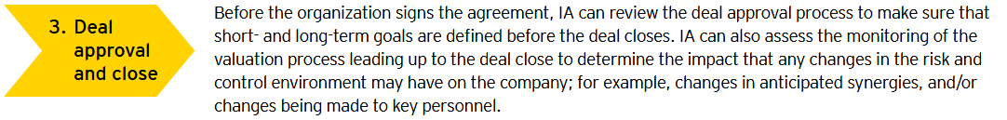

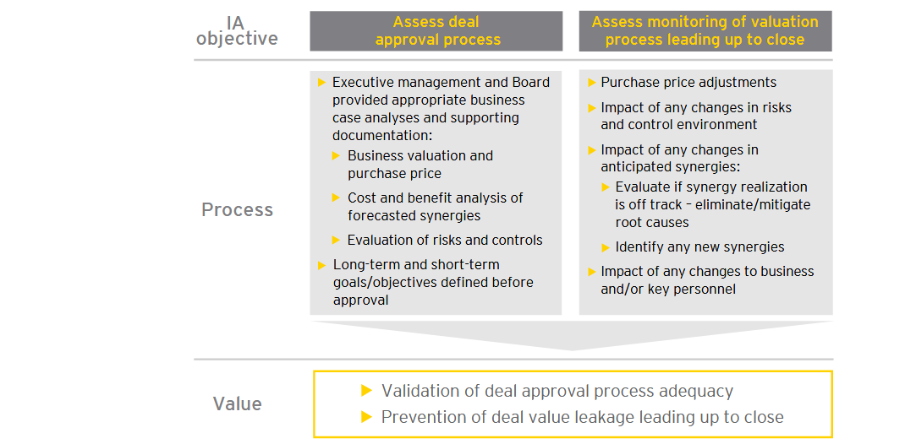

#### Integration

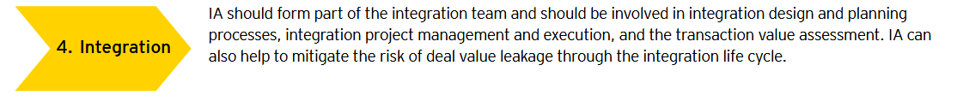

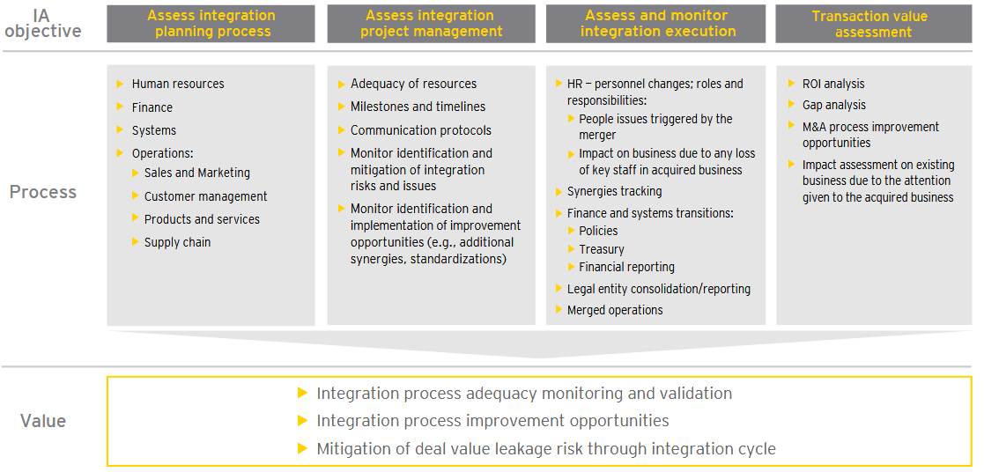

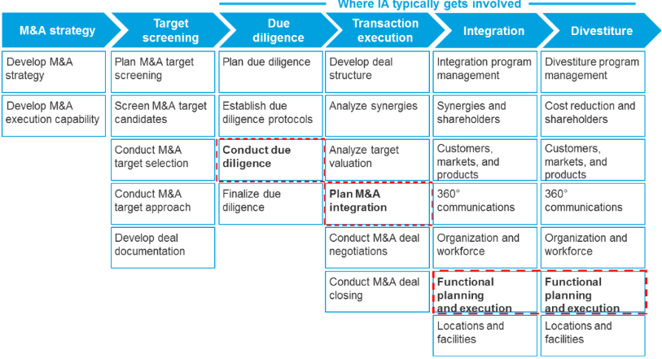

## Audit Agile Projects

**Audit data**: ➊**Development**. Ensure it is planned using agile planning / continuous integration; changes are communicated across teams; environments appropriate & available timely; watch rework following redesign / after bug fixing; watch process to get customer or business change into an assessment: how fast? barriers and points where project fails to perform ➋**Design**. Ensure there IS a design process, no programming hacking without design considerations, design is shared, is performed in agile, change is performed, change is welcomed and encouraged where necessary, daily meetings record element of design changes sufficient for audit ➌**Management**. Ensure delivered using agile approach, commitments are examined, daily meetings taking place, assessments being performed, teams engaged, manager regularly examining team, coaching taking place, all management stakeholders are in place, communicating their commitment, and team is delivering in high performance manner ➍**Process**. Understand if commitments made at the outset are being maintained. Examine how well the agile approach is improving the performance of the project delivery environment and therefore the organisation. **Auditing Guidelines** ➊Audit be non-intrusive ➋Audit not trigger creation of for-Auditor-only documents ➌Generic Scrum checklist tailored to project requirements as basis for audit ➍Auditor is assigned to an entire Sprint per Internal Audit Plan ➎Auditor silent observer of Sprint ➏Auditor added to team mailing list to receive all communications; provided access to all artifacts; attends Sprint Planning, a few Daily Scrum meetings, Sprint Review, Sprint Retrospective meetings. ➐Auditor not schedule formal audit meetings with team members but seek clarifications from ScrumMaster and/or Product Owner during Sprint. ➑Auditors prepare audit report recording their observations and findings against the items in the checklist. Encouraged to go beyond checklist and provide suggestions for improvement. Audit Report presented to Team preferably immediately after Sprint Retrospective meeting. ➒Non-conformances are addressed in forthcoming Sprints and verified by the Auditor.

## Audit AI

**Framework Strategy**: Does the organization have a defined strategy? Is it investing in AI research and development? Does it have plans in place to identify and address AI threats and opportunities? **AI Components** ➊**AI Governance**: structures, processes, procedures implemented to direct, manage, and monitor the AI activities ➋**Data Architecture and Infrastructure**: how data is accessed data is accessible (metadata, taxonomy, unique identifiers, naming conventions)? Information privacy and security throughout the data lifecycle (data collection, use, storage, destruction)? Roles and responsibilities for data ownership & use throughout the data lifecycle? ➌**Data Quality**: completeness, accuracy, and reliability of the data on which AI algorithms are built ➍**AI Performance** ➎**Human Factor**: Risk of unintended human biases factored into AI design is identified and managed ? AI tested to ensure that results reflect the original objective? AI technologies can be transparent given the complexity involved? AI output is being used legally, ethically, responsibly ➏**Black Box Factor**: Type III/Type IV AI technologies — utilizing machines or platforms that can learn on their own or communicate with each other

## Audit Big Data

#### Stakeholders



#### Risk and Control

##### Program governance

**Key Risk:** Lack of appropriate management support, funding, and/or governance over big data program can expose org. to undue risk or failure to meet strategic goals

**Control Activities**

* Funding should be adequate to support business needs.
* Program objectives should support enterprisewide strategy initiatives.
* Management should receive metrics that demonstrate achievement of goals.
* The organization should establish a governing entity to manage the big data strategy.
* There should be agreed-upon SLAs between the business and IT to describe and measure performance expectations.
* Business and technical requirements should be documented, analyzed, and approved.
* Executive management should develop big data strategy that provides solutions across org.
* Prior to approving the business case, management should conduct a proof of concept to validate that the systems designs align with strategic goals.
* Roles and responsibilities should be clear and well defined.
* Organization should provide necessary resources to deploy and maintain the big data strategy.
* Third-party vendor management best practices should be used to manage big data suppliers.

##### Technology availability and performance

**Key Risk:** Ineffective technology solutions and/or configurations may result in a negative customer experience, reduced system availability, and/or degraded performance.

**Control Activities**

* IT operations should be structured in a manner that supports big data service level expectations.
* Data lifecycle policies and procedures should be documented and followed.
* Big data systems should be part of the maintenance strategy.
* Big data systems should be part of the change management strategy.
* Big data systems should be included in the patch management strategy.
* Big data systems should be procured, built, and/or configured in alignment with the complexity and demands documented in the business case.
* Systems and support tools should be configured to provide automatic notifications to support personnel.
* Reporting tools should be configured to be flexible, intuitive, and easy to use; and training aids should be provided.
* Big data systems should be configured to allow flexibility and scalability without sacrificing performance.
* Periodic performance testing should be conducted and weaknesses should be remediated.
* The big data systems lifecycle should be managed properly.
* IT general controls should be assessed periodically

##### Security and privacy

**Key Risk:** Ineffective information security standards and configurations may result in unauthorized access to/ theft of data, inappropriate modifications of data, and regulatory compliance violations

**Control Activities**

* Information security management should be part of the big data strategy.
* Data security management should be part of the big data strategy.
* Third-party access should be managed properly.
* Data privacy should be part of the big data strategy

##### Data quality, management, and reporting

**Key Risk:** Data quality issues and/or inaccurate reporting may lead to inaccurate management reporting and flawed decision making.

**Control Activities**

* Policies and procedures should be established to ensure data quality.
* Policies and procedures should be established to ensure that data obtained from third parties complies with data quality standards.
* Policies and procedures should be established to ensure reporting accuracy.
* Access to reports should be granted based on business needs.
* Reporting tools and procedures should allow for flexibility and ad-hoc reporting.
* Users should be trained periodically to maximize report utility.
* Selection of vendors who provide reporting products & services should align with business needs

## Audit Cloud





#### Security Controls



#### Auditing SAAS

•Customisable reports •Application Functionality Configuration options •Application Security configuration options (aka ERP configurable controls) •User driven data export /interface capabilities •Limited or nil involvement in application development life cycle •CAAT development is challenging •Logs for access controls, Transaction activity, Change management etc. •Existence of myriad of logs •Need automation to map controls to Key Risk Indicators – KRIs •Opportunities to leverage cloud infrastructure - it is more cost effective and efficient to develop on demand , elastic audit databases, implement audit automation





#### Context



#### Risks

➊Account lock-out/resource hijacking? ➋Misconfiguration leading to breach (e.g. S3)? ➌Loss of control? ➍Asymmetries between the provider and customer? ➎Comingling of data / multi-tenancy? ➏Jurisdictional? ➐Who should make risk decisions?

#### Service Layer

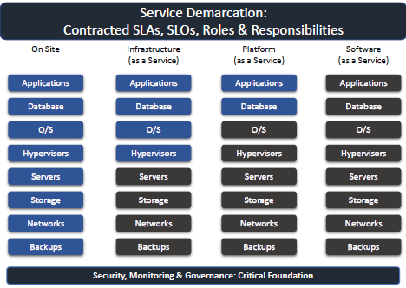

#### IT Functions

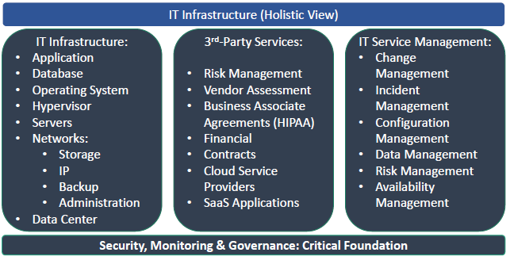

#### Incident Management

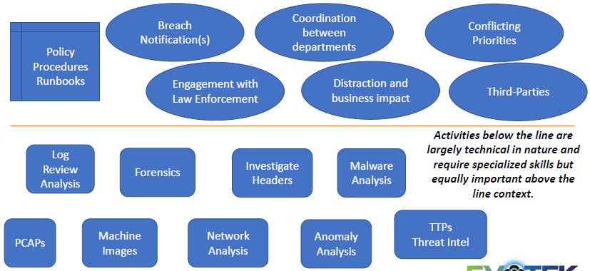

## Audit Cyber Security

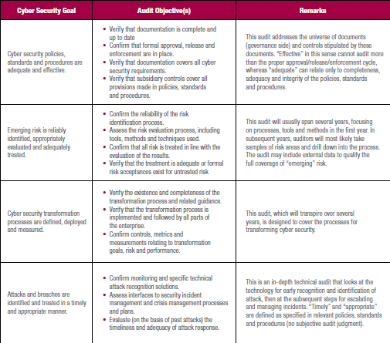

#### Three Lines of Defence

##### Common First Line of Defense Activities

* Administer security procedures, training, and testing
* Maintain secure device configurations, up-to-date software, security patches
* Deploy intrusion detection systems and conduct penetration testing
* Securely configure the network to adequately manage and protect network traffic flow
* Inventory information assets, technology devices, and related software
* Deploy data protection and loss prevention programs with related monitoring
* Restrict least-privilege access roles
* Encrypt data where feasible
* Implement vulnerability management with internal and external scans
* Recruit and retain certified IT, IT risk, and information security talent

##### Common Second Line of Defense Activities

* Design cybersecurity policies, training, and testing
* Conduct cyber risk assessments
* Gather cyber threat intelligence
* Classify data and design least-privilege access roles
* Monitor incidents, key risk indicators, and remediation
* Recruit and retain certified IT risk talent
* Assess relationships with third parties, suppliers, and service providers
* Plan/test business continuity, and participate in disaster recovery exercises and tests

##### Common Third Line of Defense Activities

* Provide independent ongoing evaluations of preventive and detective measures related to cybersecurity
* Evaluate IT assets of users with privileged access for standard security configurations, problematic websites, malicious software, and data exfiltration
* Track diligence of remediation
* Conduct cyber risk assessments of service organizations, third parties, and suppliers (note: first and second lines of defense share this ongoing responsibility)

##### Red Flags Signal Potential Governance Gaps

* Disparate, fragmented governance structure
* Incomplete strategy
* Delays of cybersecurity effort
* Budget cuts and attrition
* Unclear resolve to enforce accountability

##### Cybersecurity Risk Assessment Framework

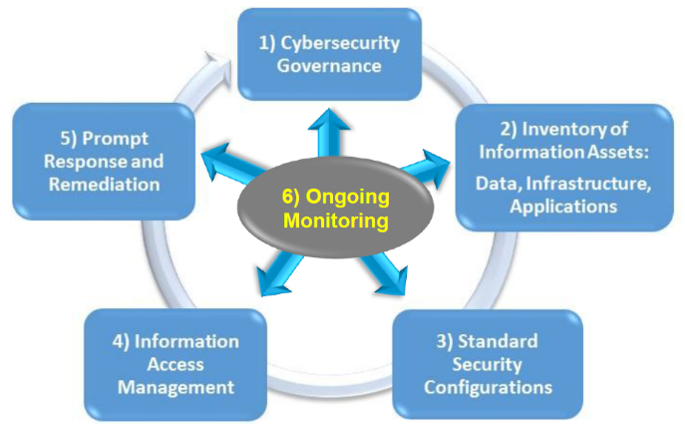

## Audit DEVOPS-CI/CD

#### CircleCI

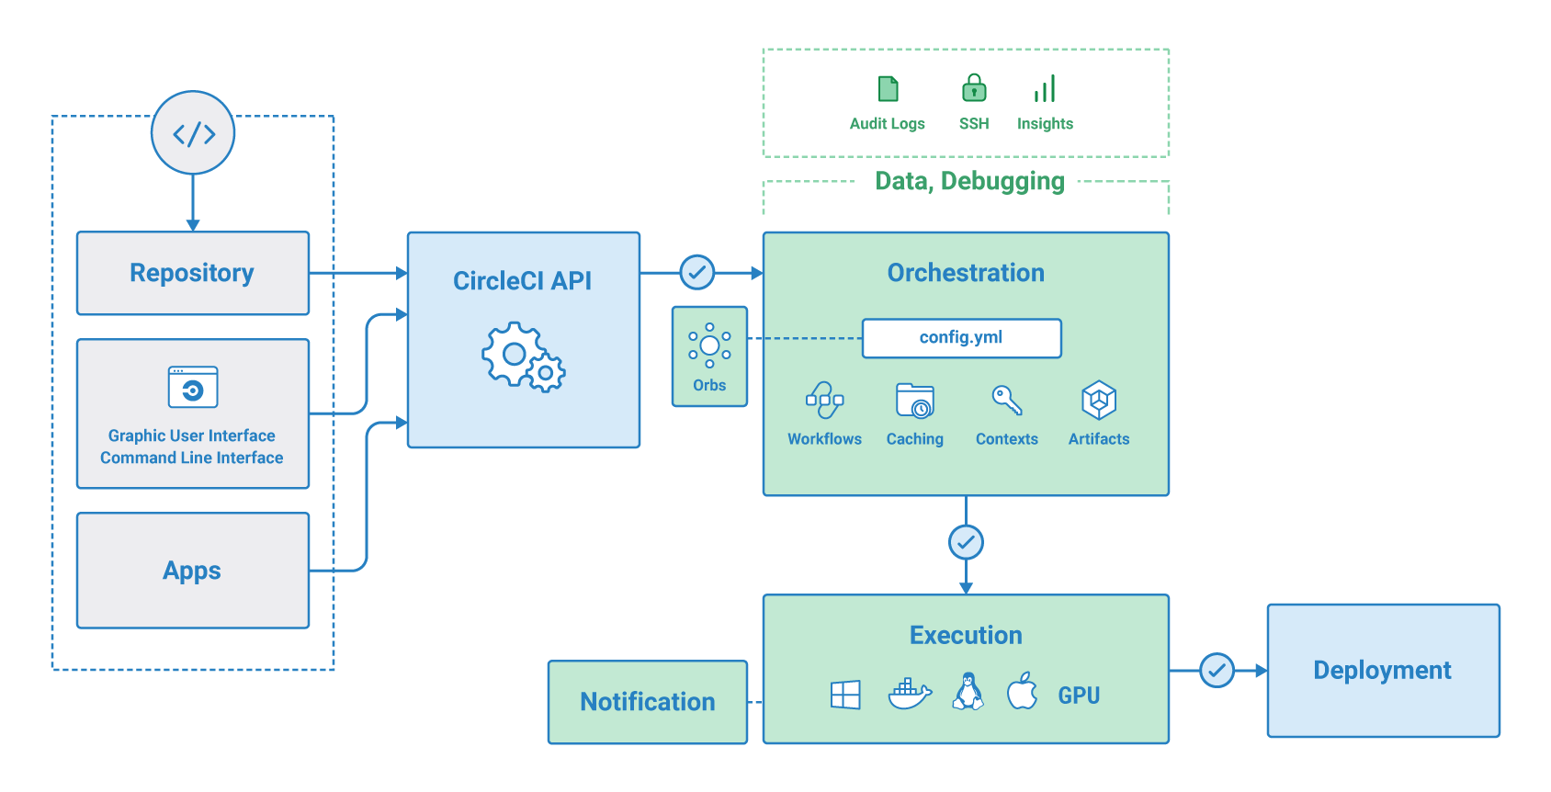

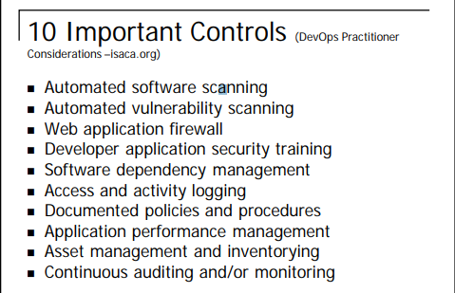

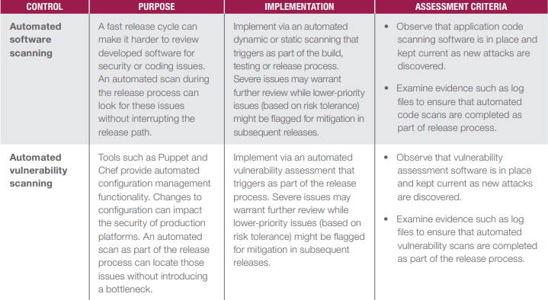

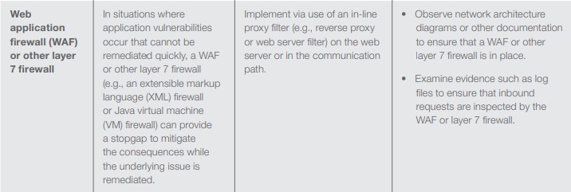

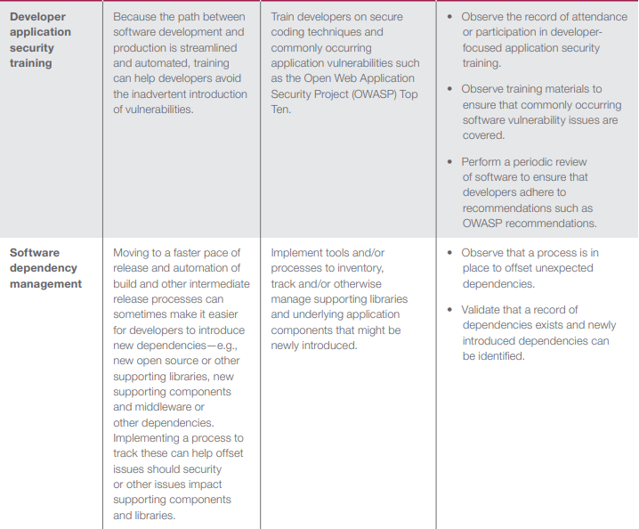

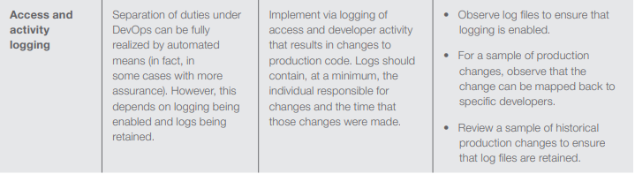

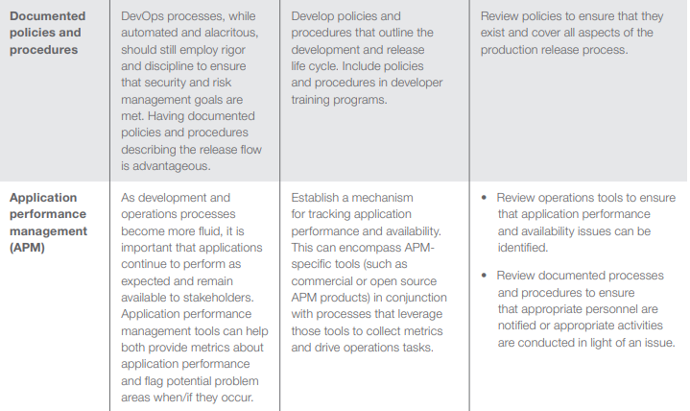

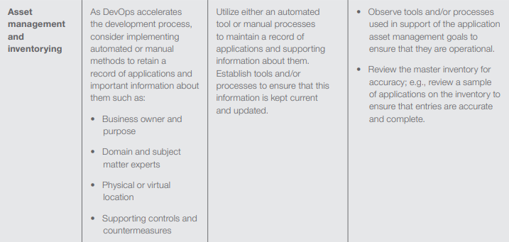

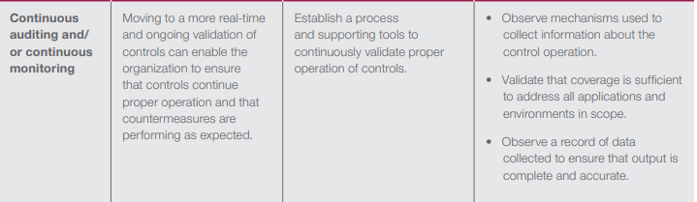

# TECHNOLOGY

## AWS

•**Elastic Compute Cloud (EC2)**, a service for provisioning computing resources on

demand •**Elastic Load Balancing (ELB)** distributes traffic to a bunch of servers behind it. Highly available by default.•**Simple Storage Service (S3)**, online storage for opaque data •**Elastic Block Store (EBS)**, persistent disk-like storage for EC2 instances, in 2008 •**Elastic MapReduce (EMR)**, a service providing Hadoop-like clusters for running MapReduce (and later Apache Hive and Apache Pig) jobs, in 2009 •**Relational Database Service (RDS)**, a service for managing relational database server instances running in AWS, also in 2009 ⬩**Instance types**: heavy compute capability, vast storage, economy, or simply general-purpose use ⬩**Availability zones** independent within a region, but faster interconnections ⬩**Temporary instance** can disappear after some time ⬩**Images** what instances are running: operating system type and version, the software packages that are available, and applications that are installed. These considerations are all bundled up into images ⬩**Security groups** AWS service to control network traffic like a firewall. Security groups can be attached to services like ELB, EC2, and RDS. With security groups, configure load balancer so that it only accepts requests on port 80 from the internet, web servers only accept connections on port 80 from the load balancer, and MySQL only accepts connections on port 3306 from the web servers. If you want to log in to your web servers via SSH, you must also open port 22. ⬩**CIDR** (Classless Inter-Domain Routing)

**AWS in Action**

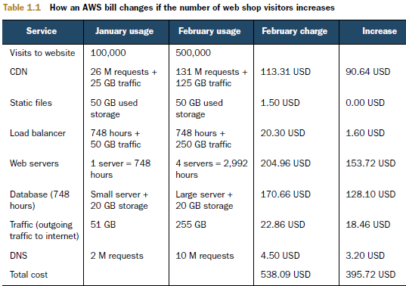

|  |  |
| --- | --- |
|  |  |

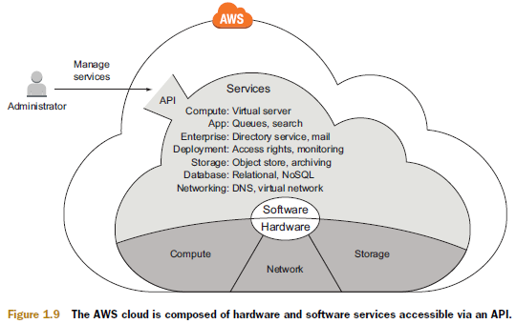

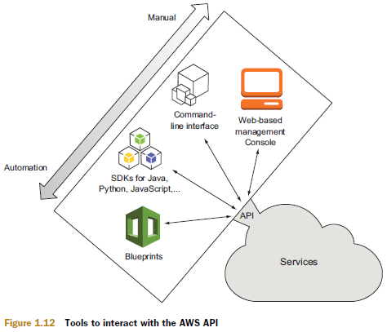

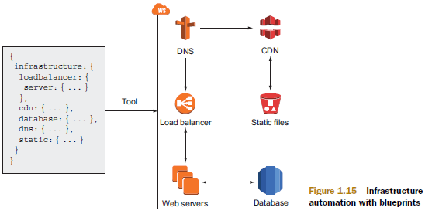

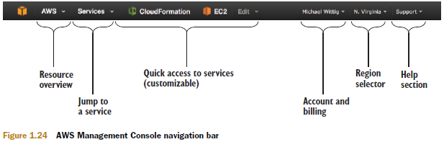

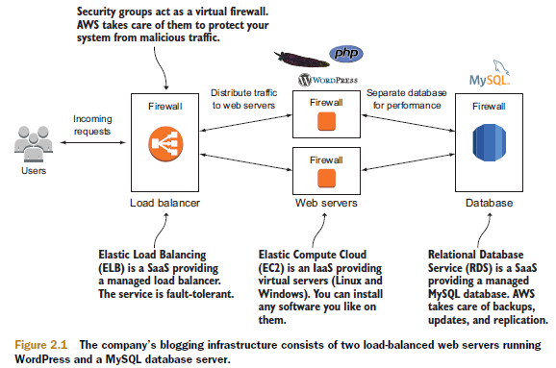

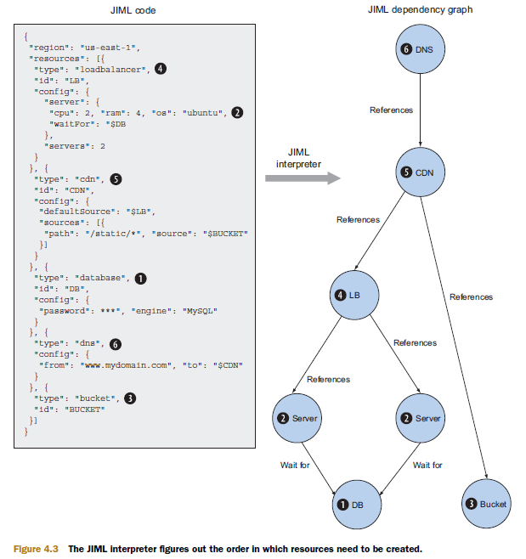

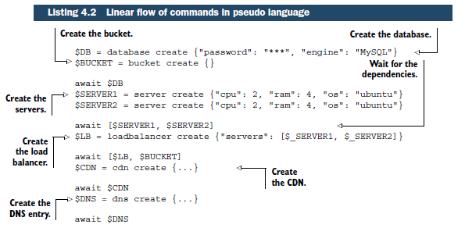

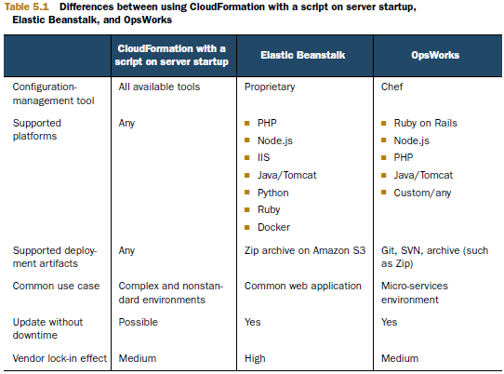

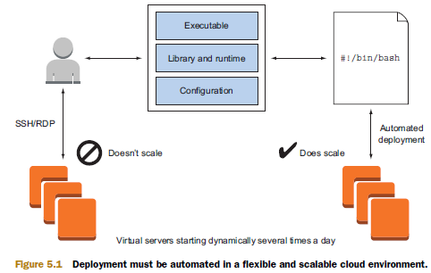

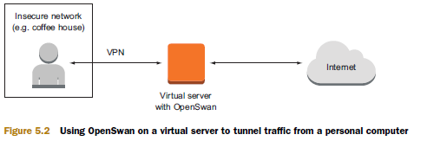

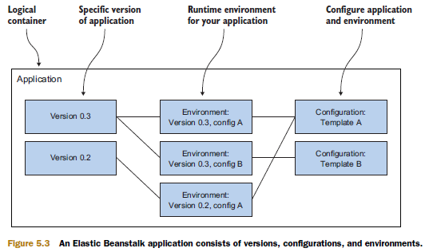

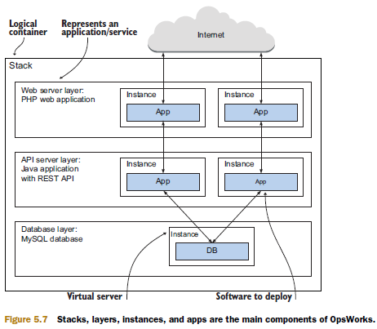

## HADOOPP

Key Features: ➊**HDFS** (Hadoop Distributed File System) adapted to work with huge or large scale bandwidth ➋**MapReduce**: Set up model for the processing of Big Data ➌**YARN**: resource scheduler or assistant for Hadoop resource management ➍**Hadoop Libraries**: enables third party programs to work with Hadoop

## STREAM

Emerging use cases for Spark and Kafka: •**ETL and data engineering**: Data preparation for all analytics •**AI and machine learning**: Massively scalable, parallel processing •**Business Intelligence**: Next-generation business intelligence with big and fast data •**Streaming apps**: Real-time processing of streaming data for the internet of things, artificial intelligence (AI) and natural language processing (NLP).

## SPARK

#### Core

Spark Core is the foundation of the overall project. It provides distributed task dispatching, scheduling, and basic [I/O](https://en.wikipedia.org/wiki/I/O_interface) functionalities, exposed through an application programming interface (for [Java](https://en.wikipedia.org/wiki/Java_(programming_language)), [Python](https://en.wikipedia.org/wiki/Python_(programming_language)), [Scala](https://en.wikipedia.org/wiki/Scala_(programming_language)), and [R](https://en.wikipedia.org/wiki/R_(programming_language))) centered on the RDD [abstraction](https://en.wikipedia.org/wiki/Abstraction_(computer_science)) (the Java API is available for other JVM languages, but is also usable for some other non-JVM languages that can connect to the JVM, such as [Julia](https://en.wikipedia.org/wiki/Julia_(programming_language))[[16]](https://en.wikipedia.org/wiki/Apache_Spark#cite_note-16)). This interface mirrors a [functional](https://en.wikipedia.org/wiki/Functional_programming)/[higher-order](https://en.wikipedia.org/wiki/Higher-order_programming) model of programming: a "driver" program invokes parallel operations such as map, [filter](https://en.wikipedia.org/wiki/Filter_(computer_science)) or reduce on an RDD by passing a function to Spark, which then schedules the function's execution in parallel on the cluster.[[2]](https://en.wikipedia.org/wiki/Apache_Spark#cite_note-hc10-2) These operations, and additional ones such as [joins](https://en.wikipedia.org/wiki/Join_(database)), take RDDs as input and produce new RDDs. RDDs are [immutable](https://en.wikipedia.org/wiki/Immutable_object) and their operations are [lazy](https://en.wikipedia.org/wiki/Lazy_evaluation); fault-tolerance is achieved by keeping track of the "lineage" of each RDD (the sequence of operations that produced it) so that it can be reconstructed in the case of data loss. RDDs can contain any type of Python, Java, or Scala objects.

Besides the RDD-oriented functional style of programming, Spark provides two restricted forms of shared variables: *broadcast variables* reference read-only data that needs to be available on all nodes, while *accumulators* can be used to program reductions in an [imperative](https://en.wikipedia.org/wiki/Imperative_programming) style.[[2]](https://en.wikipedia.org/wiki/Apache_Spark#cite_note-hc10-2) A typical example of RDD-centric functional programming is the following Scala program that computes the frequencies of all words occurring in a set of text files and prints the most common ones. Each map, flatMap (a variant of map) and reduceByKey takes an [anonymous function](https://en.wikipedia.org/wiki/Anonymous_function) that performs a simple operation on a single data item (or a pair of items), and applies its argument to transform an RDD into a new RDD.

**val** conf **=** **new** **SparkConf**().setAppName("wiki_test") // create a spark config object

**val** sc **=** **new** **SparkContext**(conf) // Create a spark context

**val** data **=** sc.textFile("/path/to/somedir") // Read files from "somedir" into an RDD of (filename, content) pairs.

**val** tokens **=** data.flatMap(**_**.split(" ")) // Split each file into a list of tokens (words).

**val** wordFreq **=** tokens.map((**_**, **1**)).reduceByKey(**_** + **_**) // Add a count of one to each token, then sum the counts per word type.

wordFreq.sortBy(s **=>** -s._2).map(x **=>** (x._2, x._1)).top(**10**) // Get the top 10 words. Swap word and count to sort by count.

#### SQL

Spark [SQL](https://en.wikipedia.org/wiki/SQL) is a component on top of Spark Core that introduced a data abstraction called DataFrames,[[a]](https://en.wikipedia.org/wiki/Apache_Spark#cite_note-18) which provides support for structured and [semi-structured data](https://en.wikipedia.org/wiki/Semi-structured_data). Spark SQL provides a [domain-specific language](https://en.wikipedia.org/wiki/Domain-specific_language) (DSL) to manipulate DataFrames in [Scala](https://en.wikipedia.org/wiki/Scala_(programming_language)), [Java](https://en.wikipedia.org/wiki/Java_(programming_language)), or [Python](https://en.wikipedia.org/wiki/Python_(programming_language)). It also provides SQL language support, with [command-line interfaces](https://en.wikipedia.org/wiki/Command-line_interface) and [ODBC](https://en.wikipedia.org/wiki/Open_Database_Connectivity)/[JDBC](https://en.wikipedia.org/wiki/Java_Database_Connectivity) server. Although DataFrames lack the compile-time type-checking afforded by RDDs, as of Spark 2.0, the strongly typed DataSet is fully supported by Spark SQL as well.

**import** **org.apache.spark.sql.SparkSession**

**val** url **=** "jdbc:mysql://yourIP:yourPort/test?user=yourUsername;password=yourPassword" // URL for your database server.

**val** spark **=** **SparkSession**.builder().getOrCreate() // Create a Spark session object

**val** df **=** spark

.read

.format("jdbc")

.option("url", url)

.option("dbtable", "people")

.load()

df.printSchema() // Looks the schema of this DataFrame.

**val** countsByAge **=** df.groupBy("age").count() // Counts people by age

//or alternatively via SQL:

//df.createOrReplaceTempView("people")

//val countsByAge = spark.sql("SELECT age, count(*) FROM people GROUP BY age")

#### Streaming

park Streaming uses Spark Core's fast scheduling capability to perform [streaming analytics](https://en.wikipedia.org/wiki/Event_stream_processing). It ingests data in mini-batches and performs RDD transformations on those mini-batches of data. This design enables the same set of application code written for batch analytics to be used in streaming analytics, thus facilitating easy implementation of [lambda architecture](https://en.wikipedia.org/wiki/Lambda_architecture). However, this convenience comes with the penalty of latency equal to the mini-batch duration. Other streaming data engines that process event by event rather than in mini-batches include [Storm](https://en.wikipedia.org/wiki/Storm_(event_processor)) and the streaming component of [Flink](https://en.wikipedia.org/wiki/Apache_Flink).[[20]](https://en.wikipedia.org/wiki/Apache_Spark#cite_note-21) Spark Streaming has support built-in to consume from [Kafka](https://en.wikipedia.org/wiki/Apache_Kafka), [Flume](https://en.wikipedia.org/wiki/Apache_Flume), [Twitter](https://en.wikipedia.org/wiki/Twitter#Implementation), [ZeroMQ](https://en.wikipedia.org/wiki/ZeroMQ), [Kinesis](https://en.wikipedia.org/wiki/Amazon_Web_Services#Database), and [TCP/IP sockets](https://en.wikipedia.org/wiki/Network_socket).[[21]](https://en.wikipedia.org/wiki/Apache_Spark#cite_note-22) In Spark 2.x, a separate technology based on Datasets, called Structured Streaming, that has a higher-level interface is also provided to support streaming.[[22]](https://en.wikipedia.org/wiki/Apache_Spark#cite_note-23)

#### Mlib Machine Learning Library

Spark MLlib is a [distributed](https://en.wikipedia.org/wiki/Distributed_computing) machine-learning framework on top of Spark Core that, due in large part to the distributed memory-based Spark architecture, is as much as nine times as fast as the disk-based implementation used by [Apache Mahout](https://en.wikipedia.org/wiki/Apache_Mahout) (according to benchmarks done by the MLlib developers against the [alternating least squares](https://en.wikipedia.org/wiki/Linear_regression) (ALS) implementations, and before Mahout itself gained a Spark interface), and [scales](https://en.wikipedia.org/wiki/Scale_(computing)) better than [Vowpal Wabbit](https://en.wikipedia.org/wiki/Vowpal_Wabbit).[[23]](https://en.wikipedia.org/wiki/Apache_Spark#cite_note-24) An overview of Spark MLlib is exist.[[24]](https://en.wikipedia.org/wiki/Apache_Spark#cite_note-25) Many common machine learning and statistical algorithms have been implemented and are shipped with MLlib which simplifies large scale machine learning [pipelines](https://en.wikipedia.org/wiki/Pipeline_(software)), including:

* [summary statistics](https://en.wikipedia.org/wiki/Summary_statistics), [correlations](https://en.wikipedia.org/wiki/Correlation_and_dependence), [stratified sampling](https://en.wikipedia.org/wiki/Stratified_sampling), [hypothesis testing](https://en.wikipedia.org/wiki/Hypothesis_testing), random data generation[[25]](https://en.wikipedia.org/wiki/Apache_Spark#cite_note-26)
* [classification](https://en.wikipedia.org/wiki/Statistical_classification) and [regression](https://en.wikipedia.org/wiki/Regression_analysis): [support vector machines](https://en.wikipedia.org/wiki/Support_vector_machines), [logistic regression](https://en.wikipedia.org/wiki/Logistic_regression), [linear regression](https://en.wikipedia.org/wiki/Linear_regression), decision trees, [naive Bayes classification](https://en.wikipedia.org/wiki/Naive_Bayes_classifier)
* [collaborative filtering](https://en.wikipedia.org/wiki/Collaborative_filtering) techniques including alternating least squares (ALS)
* [cluster analysis methods](https://en.wikipedia.org/wiki/Cluster_analysis) including [k-means](https://en.wikipedia.org/wiki/K-means_clustering), and [latent Dirichlet allocation](https://en.wikipedia.org/wiki/Latent_Dirichlet_allocation) (LDA)
* [dimensionality reduction techniques](https://en.wikipedia.org/wiki/Dimensionality_reduction) such as [singular value decomposition](https://en.wikipedia.org/wiki/Singular_value_decomposition) (SVD), and [principal component analysis](https://en.wikipedia.org/wiki/Principal_component_analysis) (PCA)
* [feature extraction](https://en.wikipedia.org/wiki/Feature_extraction) and [transformation](https://en.wikipedia.org/wiki/Data_transformation_(statistics)) functions
* [optimization](https://en.wikipedia.org/wiki/Optimization_(mathematics)) algorithms such as [stochastic gradient descent](https://en.wikipedia.org/wiki/Stochastic_gradient_descent), [limited-memory BFGS](https://en.wikipedia.org/wiki/Limited-memory_BFGS) (L-BFGS)

#### GraphX

GraphX is a distributed [graph-processing](https://en.wikipedia.org/wiki/Graph_(abstract_data_type)) framework on top of Apache Spark. Because it is based on RDDs, which are immutable, graphs are immutable and thus GraphX is unsuitable for graphs that need to be updated, let alone in a transactional manner like a [graph database](https://en.wikipedia.org/wiki/Graph_database).[[26]](https://en.wikipedia.org/wiki/Apache_Spark#cite_note-27) GraphX provides two separate APIs for implementation of massively parallel algorithms (such as [PageRank](https://en.wikipedia.org/wiki/PageRank)): a [Pregel](https://en.wikipedia.org/wiki/Graph_database#Distributed_processing) abstraction, and a more general MapReduce-style API.[[27]](https://en.wikipedia.org/wiki/Apache_Spark#cite_note-28) Unlike its predecessor Bagel, which was formally deprecated in Spark 1.6, GraphX has full support for property graphs (graphs where properties can be attached to edges and vertices).[[28]](https://en.wikipedia.org/wiki/Apache_Spark#cite_note-29) GraphX can be viewed as being the Spark in-memory version of [Apache Giraph](https://en.wikipedia.org/wiki/Apache_Giraph), which utilized Hadoop disk-based MapReduce.[[29]](https://en.wikipedia.org/wiki/Apache_Spark#cite_note-30) Like Apache Spark, GraphX initially started as a research project at UC Berkeley's AMPLab and Databricks, and was later donated to the Apache Software Foundation and the Spark project.[[30]](https://en.wikipedia.org/wiki/Apache_Spark#cite_note-31)

## APACHE KAFKA

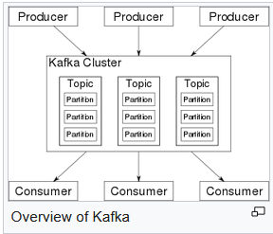

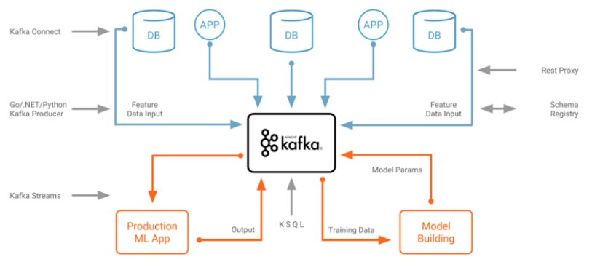

Kafka stores key-value messages that come from arbitrarily many processes called *producers*. The data can be partitioned into different "partitions" within different "topics". Within a partition, messages are strictly ordered by their offsets (the position of a message within a partition), and indexed and stored together with a timestamp. Other processes called "consumers" can read messages from partitions. For stream processing, Kafka offers the Streams API that allows writing Java applications that consume data from Kafka and write results back to Kafka. Apache Kafka also works with external stream processing systems such as [Apache Apex](https://en.wikipedia.org/wiki/Apache_Apex), [Apache Flink](https://en.wikipedia.org/wiki/Apache_Flink), [Apache Spark](https://en.wikipedia.org/wiki/Apache_Spark), and [Apache Storm](https://en.wikipedia.org/wiki/Apache_Storm). Kafka runs on a cluster of one or more servers (called brokers), and the partitions of all topics are distributed across the cluster nodes. Additionally, partitions are replicated to multiple brokers. This architecture allows Kafka to deliver massive streams of messages in a fault-tolerant fashion and has allowed it to replace some of the conventional messaging systems like [Java Message Service](https://en.wikipedia.org/wiki/Java_Message_Service) (JMS), [Advanced Message Queuing Protocol](https://en.wikipedia.org/wiki/Advanced_Message_Queuing_Protocol) (AMQP), etc. Since the 0.11.0.0 release, Kafka offers *transactional writes*, which provide exactly-once stream processing using the Streams API. Kafka supports two types of topics: ➊*Regular topics* can be configured with a retention time or a space bound. If there are records that are older than the specified retention time or if the space bound is exceeded for a partition, Kafka is allowed to delete old data to free storage space. By default, topics are configured with a retention time of 7 days, but it's also possible to store data indefinitely. ➋For *compacted topics*, records don't expire based on time or space bounds. Instead, Kafka treats later messages as updates to older message with the same key and guarantees never to delete the latest message per key. Users can delete messages entirely by writing a so-called tombstone message with null-value for a specific key. Four major APIs: ➊ **Producer API** Permits application to publish streams of records ➋ **Consumer API** Permits application to subscribe to topics and processes streams of records ➌ **Connector API** Executes the reusable producer and consumer APIs that can link the topics to the existing applications ➍ **Streams API** Converts the input streams to output and produces the result. The consumer and producer APIs build on top of the Kafka messaging protocol and offer a reference implementation for Kafka consumer and producer clients in Java. The underlying messaging protocol is a [binary protocol](https://en.wikipedia.org/wiki/Binary_protocol) that developers can use to write their own consumer or producer clients in any programming language. This unlocks Kafka from the [Java Virtual Machine](https://en.wikipedia.org/wiki/Java_Virtual_Machine) (JVM) eco-system. A list of available non-Java clients is maintained in the Apache Kafka wiki.

## DJANGO

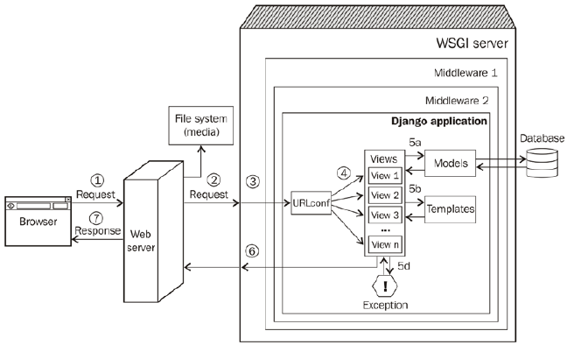

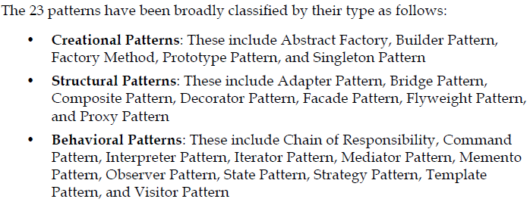

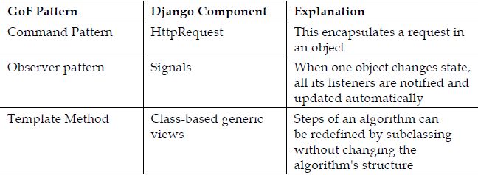

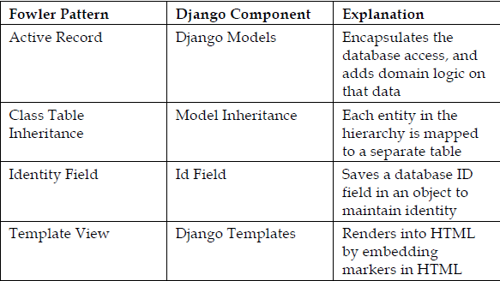

**Structural patterns**: ⬩normalized models ⬩model mixins ⬩user profiles ⬩service objects

**Retrieval patterns**: ⬩property field ⬩custom model managers **View patterns**: ⬩acces controlled ⬩context enhancers ⬩services **Template patterns**: ⬩inheritance ⬩active link

## SQL

REPL (Read-Eval-Print-Loop) instructions

## Oracle PL/SQL

##### PL/SQL anonymous block

The basic unit of a PL/SQL (Procedural Language for SQL) source program is the block, which groups together related declarations and statements. A PL/SQL block is defined by the keywords DECLARE, BEGIN, EXCEPTION, and END. These keywords divide the block into a declarative part, an executable part, and an exception-handling part. The declaration section is optional and may be used to define and initialize constants and variables. If a variable is not initialized then it defaults to [NULL](https://en.wikipedia.org/wiki/Null_(SQL)) value. The optional exception-handling part is used to handle run time errors. Only the executable part is required. A block can have a label.

**<<label>>** -- this is optional

**DECLARE**

-- this section is optional

number1 NUMBER(**2**);

number2 number1%TYPE := **17**; -- value default

text1 VARCHAR2(**12**) := 'Hello world';

text2 DATE := SYSDATE; -- current date and time

**BEGIN**

-- this section is mandatory, must contain at least one executable statement

**SELECT** street_number

**INTO** number1

**FROM** address

**WHERE** **name** = 'INU';

**EXCEPTION**

-- this section is optional

**WHEN** OTHERS **THEN**

DBMS_OUTPUT**.**PUT_LINE('Error Code is ' || TO_CHAR(sqlcode));

DBMS_OUTPUT**.**PUT_LINE('Error Message is ' || sqlerrm);

**END**;

The symbol := functions as an [assignment operator](https://en.wikipedia.org/wiki/Assignment_operator) to store a value in a variable.

Blocks can be nested – i.e., because a block is an executable statement, it can appear in another block wherever an executable statement is allowed. A block can be submitted to an interactive tool (such as SQL*Plus) or embedded within an Oracle Precompiler or [OCI](https://en.wikipedia.org/wiki/Oracle_Call_Interface) program. The interactive tool or program runs the block once. The block is not stored in the database, and for that reason, it is called an anonymous block (even if it has a label).

##### Function

PL/SQL function is generally used to compute and return a single value. This returned value may be a single scalar value (such as a number, date or character string) or a single collection (such as a nested table or array). User-defined functions supplement the built-in functions provided by Oracle Corporation.

**CREATE** **OR** **REPLACE** **FUNCTION** <function_name> [(**input**/output variable declarations)] **RETURN** return_type

[AUTHID <**CURRENT_USER** | **DEFINER**>] <**IS**|**AS**> -- heading part

amount number; -- declaration block

**BEGIN** -- executable part

<PL/SQL block **with** **return** **statement**>

**RETURN** <return_value>;

[**Exception**

**none**]

**RETURN** <return_value>;

**END**;

Pipe-lined table functions return collections[[4]](https://en.wikipedia.org/wiki/PL/SQL#cite_note-4) and take the form:

**CREATE** **OR** **REPLACE** **FUNCTION** <function_name> [(**input**/output variable declarations)] **RETURN** return_type

[AUTHID <**CURRENT_USER** | **DEFINER**>] [<**AGGREGATE** | PIPELINED>] <**IS**|**USING**>

[declaration block]

**BEGIN**

<PL/SQL block **with** **return** **statement**>

PIPE **ROW** <**return** **type**>;

**RETURN**;

[**Exception**

**exception** block]

PIPE **ROW** <**return** **type**>;

**RETURN**;

**END**;

A function should only use the default IN type of parameter. The only out value from the function should be the value it returns.

##### Procedure

Like functions, procedures are named program units that can be invoked repeatedly. The primary difference is that **functions can be used in a SQL statement whereas procedures cannot**. Another difference is that the procedure can return multiple values whereas a function should only return a single value.

The procedure begins with a mandatory heading part to hold the procedure name and optionally the procedure parameter list. Next come the declarative, executable and exception-handling parts, as in the PL/SQL Anonymous Block.

**CREATE** **PROCEDURE** create_email_address ( -- Procedure heading part begins

name1 VARCHAR2,

name2 VARCHAR2,

company VARCHAR2,

email **OUT** VARCHAR2

) -- Procedure heading part ends

**AS**

-- Declarative part begins (optional)

error_message VARCHAR2(**30**) := 'Email address is too long.';

**BEGIN** -- Executable part begins (mandatory)

email := name1 || '.' || name2 || '@' || company;

**EXCEPTION** -- Exception-handling part begins (optional)

**WHEN** VALUE_ERROR **THEN**

DBMS_OUTPUT**.**PUT_LINE(error_message);

**END** create_email_address;

The example above shows a standalone procedure - this type of procedure is created and stored in a database schema using the CREATE PROCEDURE statement. A procedure may also be created in a PL/SQL package - this is called a Package Procedure. A procedure created in a PL/SQL anonymous block is called a nested procedure. The standalone or package procedures, stored in the database, are referred to as "[stored procedures](https://en.wikipedia.org/wiki/Stored_procedure)". Procedures can have three types of parameters: IN, OUT and IN OUT.

1. An IN parameter is used as input only. An IN parameter is passed by reference, though it can be changed by the inactive program.
2. An OUT parameter is initially NULL. The program assigns the parameter value and that value is returned to the calling program.
3. An IN OUT parameter may or may not have an initial value. That initial value may or may not be modified by the called program. Any changes made to the parameter are returned to the calling program by default by copying but - with the NO-COPY hint - may be passed [by reference](https://en.wikipedia.org/wiki/Call_by_reference).

PL/SQL also supports external procedures via the Oracle database's standard ext-proc process. [[5]](https://en.wikipedia.org/wiki/PL/SQL#cite_note-5)

##### Package

Packages are groups of conceptually linked functions, procedures, variables, PL/SQL table and record TYPE statements, constants, cursors, etc. The use of packages promotes re-use of code. Packages are composed of the package specification and an optional package body. The specification is the interface to the application; it declares the types, variables, constants, exceptions, cursors, and subprograms available. The body fully defines cursors and subprograms, and so implements the specification. Two advantages of packages are:

1. Modular approach, encapsulation/hiding of business logic, security, performance improvement, re-usability. They support [object-oriented programming](https://en.wikipedia.org/wiki/Object-oriented_programming) features like function overloading and encapsulation.
2. Using package variables one can declare session level (scoped) variables since variables declared in the package specification have a session scope.

##### Trigger

A [database trigger](https://en.wikipedia.org/wiki/Database_trigger) is like a stored procedure that Oracle Database invokes automatically whenever a specified event occurs. It is a named PL/SQL unit that is stored in the database and can be invoked repeatedly. Unlike a stored procedure, you can enable and disable a trigger, but you cannot explicitly invoke it. While a trigger is enabled, the database automatically invokes it—that is, the trigger fires—whenever its triggering event occurs. While a trigger is disabled, it does not fire. You create a trigger with the CREATE TRIGGER statement. You specify the triggering event in terms of triggering statements, and the item they act on. The trigger is said to be created on or defined on the item—which is either a table, a view, a schema, or the database. You also specify the timing point, which determines whether the trigger fires before or after the triggering statement runs and whether it fires for each row that the triggering statement affects. If the trigger is created on a table or view, then the triggering event is composed of DML statements, and the trigger is called a DML trigger. If the trigger is created on a schema or the database, then the triggering event is composed of either DDL or database operation statements, and the trigger is called a system trigger. An INSTEAD OF trigger is either: A DML trigger created on a view or a system trigger defined on a CREATE statement. The database fires the INSTEAD OF trigger instead of running the triggering statement.

###### Purpose of triggers

⬩Generating derived column values automatically ⬩Enforcing referential integrity ⬩Event logging/ storing information on table access ⬩Auditing ⬩Synchronous replication of tables ⬩Security authorizations ⬩Preventing invalid transactions

##### Array handling

PL/SQL refers to [arrays](https://en.wikipedia.org/wiki/Array_data_type) as "collections". Three types: ➊ [Associative arrays](https://en.wikipedia.org/wiki/Associative_array) (Index-by tables) ➋Nested tables ➌Varrays (variable-size arrays). Programmers must specify an upper limit for varrays, but need not for index-by tables or for nested tables. The language includes several collection [methods](https://en.wikipedia.org/wiki/Method_(computer_science)) used to manipulate collection elements f. ex. FIRST, LAST, NEXT, PRIOR, EXTEND, TRIM, DELETE, etc. Index-by tables can be used to simulate associative arrays, as in this [example of a memo function for Ackermann's function in PL/SQL](https://en.wikipedia.org/wiki/Ackermann_function#cite_note-10).

###### Associative arrays (index-by tables)

Index-by tables can be indexed by numbers or strings. It parallels a [Java](https://en.wikipedia.org/wiki/Java_(programming_language)) *map*, which comprises key-value pairs. There is only one dimension and is unbounded.

###### Nested tables

With nested tables, needs to understand what is nested. Here, a new type is created that may be composed of a number of components. That type can then be used to make a column in a table, and nested within that column are those components.

###### Varrays (variable-size arrays)

In Varrays, "variable" in "variable-size arrays" doesn't apply to the size of the array in the way you might think that it would. The size the array is declared with is in fact fixed. The number of elements in the array is variable up to the declared size. Arguably then, variable-sized arrays aren't that variable in size.

##### Cursors

A [cursor](https://en.wikipedia.org/wiki/Cursor_(databases)) is a mechanism, pointer to a private SQL area that stores information coming from a SELECT or data manipulation language (DML) statement (INSERT, UPDATE, DELETE, or MERGE). A [cursor](https://en.wikipedia.org/wiki/Cursor_(databases)) holds the rows (one or more) returned by a SQL statement. The set of rows the [cursor](https://en.wikipedia.org/wiki/Cursor_(databases)) holds is referred to as the active set.[[7]](https://en.wikipedia.org/wiki/PL/SQL#cite_note-7) A [cursor](https://en.wikipedia.org/wiki/Cursor_(databases)) can be explicit or implicit. In a FOR loop, an explicit cursor shall be used if the query will be reused, otherwise an implicit cursor is preferred. If using a cursor inside a loop, use a FETCH is recommended when needing to bulk collect or when needing dynamic SQL.

## T-SQL

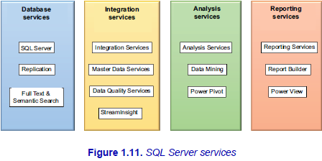

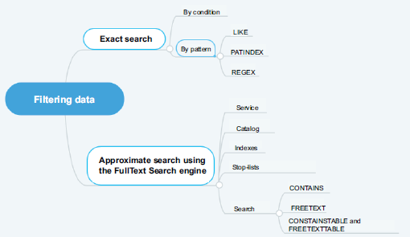

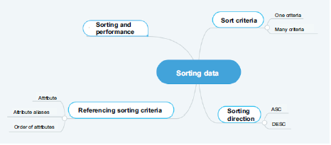

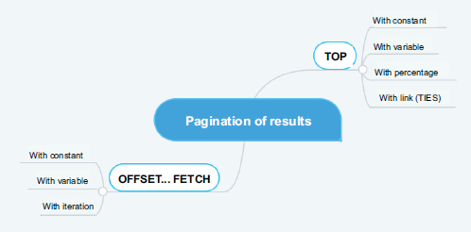

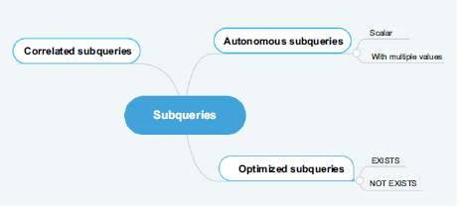

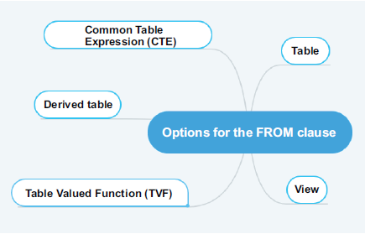

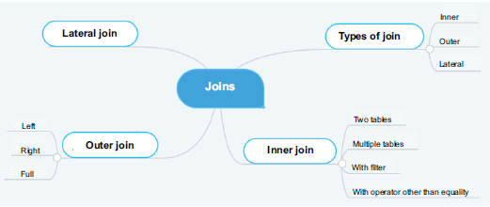

#### INNER JOIN

**USE** AdventureWorks2014

**GO**

**SELECT** P.Name **AS** Product,

SC.Name **AS** Subcategory

**FROM** Production.Product **AS** P

**JOIN** Production**.**ProductSubcategory **AS** SC

**ON** (P**.**ProductSubcategoryID **=** SC**.**ProductSubcategoryID);

**GO**

#### LEFT OUTER JOIN

**USE** AdventureWorks2014;

**GO**

**SELECT** P.Name **AS** Product,

SC.Name **AS** SubCategory

**FROM** Production.Product **AS** P

**LEFT OUTER JOIN** Production**.**ProductSubcategory **AS** SC

**ON (**P**.**ProductSubcategoryID **=** SC**.**ProductSubcategoryID);

**GO**

#### FULL OUTER JOIN

**USE** AdventureWorks2014;

**GO**

**SELECT** P.Name **AS** Product,

SC.Name **AS** SubCategory

**FROM** Production.Product **AS** P

**FULL OUTER JOIN** Production**.**ProductSubcategory **AS** SC

**ON (**P**.**ProductSubcategoryID **=** SC**.**ProductSubcategoryID);

**GO**

#### CARTESIAN PRODUCT

**USE** AdventureWorks2014

**SELECT** P.Name **AS** Product,

SC.Name **AS** SubCategory

**FROM** Production.Product **AS** P

**CROSS JOIN** Production**.**ProductSubcategory **AS** SC

#### LATERAL JOIN (CROSS APPLY)

**SELECT** P.Name **AS** Product,

F.Name **AS** SubCategory

**FROM** Production**.**ProductSubcategory **AS** SC

**CROSS APPLY** UF_PRD **(**sc**.**ProductSubcategoryID**) AS** F

**GO**

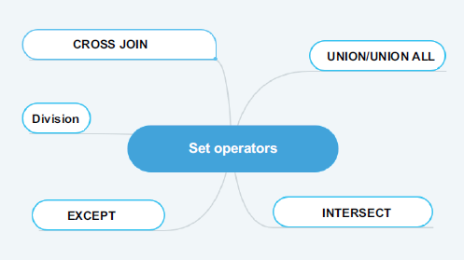

#### UNION ALL

**-- Display of all employees and salespeople.**

**SELECT** P.FirstName**,** P.MiddleName**,**P.LastName

**FROM** HumanResources**.**Employee **AS** E

**JOIN** Person**.**Person **AS** P

**ON (**E**.**BusinessEntityID **=** P.BusinessEntityID**)**

**-- The first request returns 290 employees.**

**UNION ALL**

**SELECT** P.FirstName**,** P.MiddleName**,** P.LastName

**FROM** Sales**.**SalesPerson **AS** SP

**JOIN** Person**.**Person **AS** P

**ON (**SP.BusinessEntityID **=** P.BusinessEntityID**)**

**-- The second request returns 17 salespeople.**

**GO**

**-- The union with duplicates returns 307 lines**

**-- (employees and salespeople).**

#### UNION

**-- Display of all employees and salespeople.**

**SELECT** P.FirstName**,** P.MiddleName**,** P.LastName

**FROM** HumanResources**.**Employee **AS** E

**JOIN** Person**.**Person **AS** P

**ON (**E**.**BusinessEntityID **=** P.BusinessEntityID**)**

**-- The first request returns 290 employees.**

**UNION**

**SELECT** P.FirstName**,** P.MiddleName**,** P.LastName

**FROM** Sales**.**SalesPerson **AS** SP

**JOIN** Person**.**Person **AS** P

**ON (**SP.BusinessEntityID **=** P.BusinessEntityID**)**

**-- The second request returns 17 salespeople.**

**GO**

**-- The union without duplicates returns 290 employees**

**-- because the salespeople are already employees.**

#### INTERSECT

**-- Display of all sales employees.**

**SELECT** P.FirstName**,** P.MiddleName**,** P.LastName

**FROM** HumanResource.Employee **AS** E

**JOIN** Person**.**Person **AS** P

**ON (**E**.** BusinessEntityID **=** P.BusinessEntityID**)**

**-- The first query returns 290 employees.**

**INTERSECT**

**SELECT** P.FirstName**,** P.MiddleName**,** P.LastName

**FROM** Sales**.**SalesPerson **AS** SP

**JOIN** Person**.**Person **AS** P

**ON (**SP.BusinessEntityID **=** P.BusinessEntityID**)**

**-- The second query returns 17 sellers.**

**GO**

**-- The intersection returns 17 sales employees**

**-- because all salespeople are already employees.**

#### EXCEPT

**-- Display non-sales employees.**

**SELECT** P.FirstName**,** P.MiddleName**,** P.LastName

**FROM** HumanResources**.**Employee **AS** E

**JOIN** Person.Person **AS** P

**ON (**E**.** BusinessEntityID **=** P.BusinessEntityID**)**

**-- The first query returns 290 employees.**

**EXCEPT**

**SELECT** P.FirstName**,** P.MiddleName**,** P.LastName

**FROM** Sales**.**SalesPerson **AS** SP

**JOIN** Person.Person **AS** P

**ON (**SP.BusinessEntityID **=** P.BusinessEntityID**)**

**-- The second query returns 17 salespeople.**

**GO**

**-- The difference returns 273 employees.**

#### PIVOT

##### Basic

USE AdventureWorks2014 ;

GO

SELECT DaysToManufacture, AVG(StandardCost) AS AverageCost

FROM Production.Product

GROUP BY DaysToManufacture;

DaysToManufacture AverageCost

----------------- -----------

0 5.0885

1 223.88

2 359.1082

4 949.4105

-- Pivot table with one row and five columns

SELECT 'AverageCost' AS Cost_Sorted_By_Production_Days,

[0], [1], [2], [3], [4]

FROM

(SELECT DaysToManufacture, StandardCost

FROM Production.Product) AS SourceTable

PIVOT

(

AVG(StandardCost)

FOR DaysToManufacture IN ([0], [1], [2], [3], [4])

) AS PivotTable;

Cost_Sorted_By_Production_Days 0 1 2 3 4

------------------------------ ----------- ----------- ----------- ----------- -----------

AverageCost 5.0885 223.88 359.1082 NULL 949.4105

##### Complex

USE AdventureWorks2014;

GO

SELECT VendorID, [250] AS Emp1, [251] AS Emp2, [256] AS Emp3, [257] AS Emp4, [260] AS Emp5

FROM

(SELECT PurchaseOrderID, EmployeeID, VendorID

FROM Purchasing.PurchaseOrderHeader) p

PIVOT

(

COUNT (PurchaseOrderID)

FOR EmployeeID IN

( [250], [251], [256], [257], [260] )

) AS pvt

ORDER BY pvt.VendorID;

VendorID Emp1 Emp2 Emp3 Emp4 Emp5

----------- ----------- ----------- ----------- ----------- -----------

1492 2 5 4 4 4

1494 2 5 4 5 4

1496 2 4 4 5 5

1498 2 5 4 4 4

1500 3 4 4 5 4

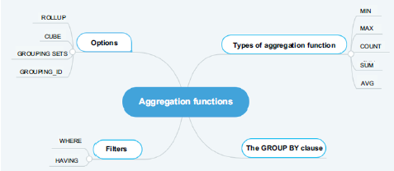

##### GROUP BY ROLLUP

SELECT

    warehouse, SUM(quantity)

FROM

    inventory

GROUP BY warehouse;

SQL ROLLUP with one column rollup example

SELECT

    warehouse, SUM(quantity)

FROM

    inventory

GROUP BY ROLLUP (warehouse);

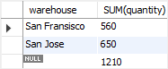

##### CUBE v ROLLUP

The **GROUP BY** clause is used to group the results of aggregate functions according to a specified column. However, the GROUP BY clause doesn’t perform aggregate operations on multiple levels of a hierarchy. F. ex., you can calculate the total of all employee salaries for each department in a company (one level of hierarchy) but you cannot calculate the total salary of all employees regardless of the department they work in (two levels of hierarchy). **ROLLUP** operators let you extend the functionality of GROUP BY clauses by calculating subtotals and grand totals for a set of columns. The **CUBE** operator is similar in functionality to the ROLLUP operator; however, the CUBE operator can calculate subtotals and grand totals for all permutations of the columns specified in it.

**ROLLUP**

1-Department and Gender

2-Department

3-Grand Total

We do not have salary grouped by Gender only. This is because gender is lowest in hierarchy.

**CUBE**

All four possible combinations:

1- Department and Gender

2- Department only

3- Gender Only

4- Grand Total.

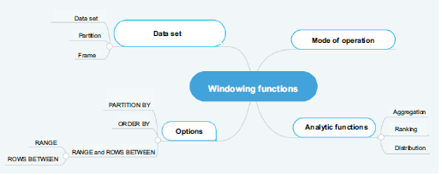

#### OVER()

AVG() window function to calculate the average sales for employees in Q1:

select emp_name, dealer_id, sales, avg(sales) over() as avgsales from q1_sales;

+-----------------+------------+--------+-----------+

| emp_name | dealer_id | sales | avgsales |

+-----------------+------------+--------+-----------+

| Beverly Lang | 2 | 16233 | 13631 |

| Kameko French | 2 | 16233 | 13631 |

| Ursa George | 3 | 15427 | 13631 |

| Ferris Brown | 1 | 19745 | 13631 |

| Noel Meyer | 1 | 19745 | 13631 |

| Abel Kim | 3 | 12369 | 13631 |

| Raphael Hull | 1 | 8227 | 13631 |

| Jack Salazar | 1 | 9710 | 13631 |

| May Stout | 3 | 9308 | 13631 |

| Haviva Montoya | 2 | 9308 | 13631 |

+-----------------+------------+--------+-----------+

AVG() window function with the PARTITION BY clause to determine the average car sales for each dealer in Q1:

select emp_name, dealer_id, sales, avg(sales) over (partition by dealer_id) as avgsales from q1_sales;

+-----------------+------------+--------+-----------+

| emp_name | dealer_id | sales | avgsales |

+-----------------+------------+--------+-----------+

| Ferris Brown | 1 | 19745 | 14357 |

| Noel Meyer | 1 | 19745 | 14357 |

| Raphael Hull | 1 | 8227 | 14357 |

| Jack Salazar | 1 | 9710 | 14357 |

| Beverly Lang | 2 | 16233 | 13925 |

| Kameko French | 2 | 16233 | 13925 |

| Haviva Montoya | 2 | 9308 | 13925 |

| Ursa George | 3 | 15427 | 12368 |

| Abel Kim | 3 | 12369 | 12368 |

| May Stout | 3 | 9308 | 12368 |

+-----------------+------------+--------+-----------+

AVG() and ROW_NUM() window functions to determine average car sales for each dealer in Q1 and assign row number to each row in partition:

select dealer_id, sales, emp_name,row_number() over (partition by dealer_id order by sales) as `row`,avg(sales) over (partition by dealer_id) as avgsales from q1_sales;

+------------+--------+-----------------+------+---------------+

| dealer_id | sales | emp_name | row | avgsales |

+------------+--------+-----------------+------+---------------+

| 1 | 8227 | Raphael Hull | 1 | 14356 |

| 1 | 9710 | Jack Salazar | 2 | 14356 |

| 1 | 19745 | Ferris Brown | 3 | 14356 |

| 1 | 19745 | Noel Meyer | 4 | 14356 |

| 2 | 9308 | Haviva Montoya | 1 | 13924 |

| 2 | 16233 | Beverly Lang | 2 | 13924 |

| 2 | 16233 | Kameko French | 3 | 13924 |

| 3 | 9308 | May Stout | 1 | 12368 |

| 3 | 12369 | Abel Kim | 2 | 12368 |

| 3 | 15427 | Ursa George | 3 | 12368 |

+------------+--------+-----------------+------+---------------+

## SQL CLR

**SQL CLR** or **SQLCLR** ([SQL](https://en.wikipedia.org/wiki/SQL) [Common Language Runtime](https://en.wikipedia.org/wiki/Common_Language_Runtime)) is technology for hosting of the Microsoft .NET common language runtime engine within SQL Server. The SQLCLR allows [managed code](https://en.wikipedia.org/wiki/Managed_code) to be hosted by, and run in, the [Microsoft SQL Server](https://en.wikipedia.org/wiki/Microsoft_SQL_Server) environment.

This technology, introduced in 2005, allow users for example to create the following types of managed code objects in SQL Server in .NET languages such as [C#](https://en.wikipedia.org/wiki/C_Sharp_(programming_language)) or [VB.NET](https://en.wikipedia.org/wiki/VB.NET).

* [Stored procedures](https://en.wikipedia.org/wiki/Stored_procedure) (SPs) which are analogous to *procedures* or *void functions* in procedural languages like VB or C,
* [Triggers](https://en.wikipedia.org/wiki/Database_trigger) which are stored procedures that fire in response to [Data Manipulation Language](https://en.wikipedia.org/wiki/Data_Manipulation_Language) (DML) or [Data Definition Language](https://en.wikipedia.org/wiki/Data_Definition_Language) (DDL) events,
* [User-defined functions](https://en.wikipedia.org/wiki/User-defined_function) (UDFs) which are analogous to functions in procedural languages,
* [User-defined aggregates](https://en.wikipedia.org/w/index.php?title=User-defined_aggregate&action=edit&redlink=1) (UDAs) which allow developers to create custom aggregates that act on sets of data instead of one row at a time,
* [User-defined types](https://en.wikipedia.org/wiki/User-defined_type) (UDTs) that allow users to create simple or complex data types which can be serialized and deserialized within the database.

The SQL CLR relies on the creation, deployment, and registration of [CLI assemblies](https://en.wikipedia.org/wiki/Assembly_(CLI)), which are physically stored in managed code dynamic load libraries (DLLs). These assemblies may contain CLI namespaces, classes, functions and properties.

## TABLEAU

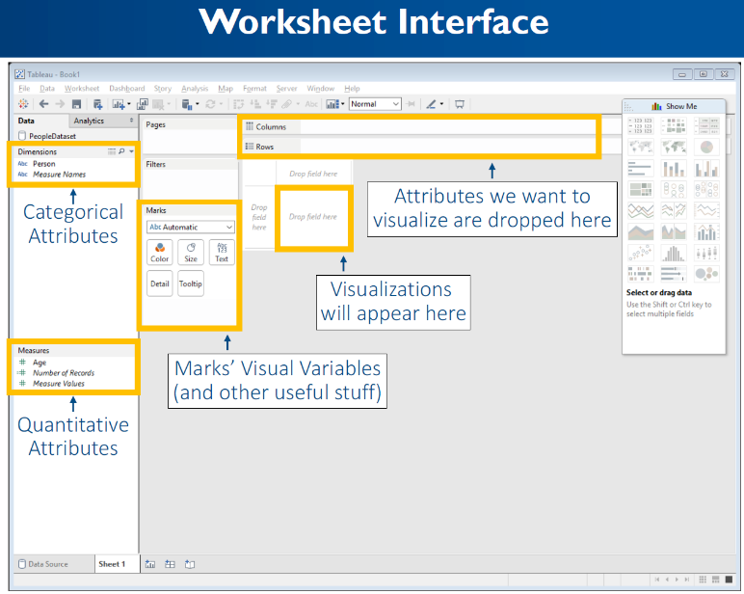

🞟**Marks card** gives control over how the data is displayed in the view. The options allow change of detail level, appearances, etc.

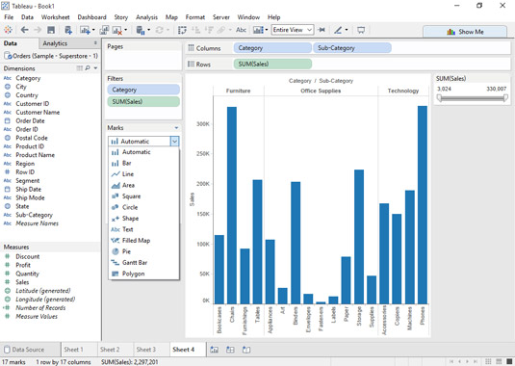

🞟**Level of Detail (LOD**) expressions are used to run complex queries involving many dimensions at the data source level instead of bringing all the data to Tableau interface. A simple example is adding dimension to an already calculated aggregate value.

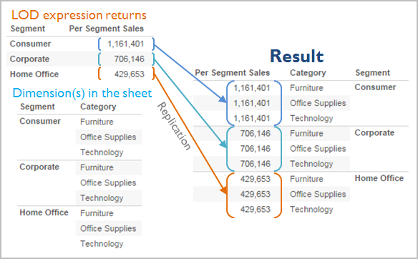

An expression has a finer level of detail than the view when it references a superset of the dimensions in the view. When you use such an expression in the view, Tableau will aggregate results up to the view level. Example: The following level of detail expression references two dimensions:

{FIXED [Segment], [Category] : SUM([Sales])}

When this expression is used in a view that has only [Segment] as its level of detail, the values must be aggregated. Here’s what you would see if you dragged that expression to a shelf:

AVG([{FIXED [Segment]], [Category]] : SUM([Sales]])}])

An aggregation—in this case, average—is automatically assigned by Tableau. You can change the aggregation as needed.

#### Workbook Components

Sheet: A sheet is a singular chart or map in Tableau. Symbol: 

Dashboard: A dashboard is a canvas for displaying multiple sheets at a time and allowing them to interact with each other. Symbol: 

Container: A container is a layout frame on a dashboard that can house sheets, images, filters/parameters, and text boxes. Containers can be horizontal (objects placed go side-by-side) or vertical (objects placed are on top of one another). Double-click any sheet on a dashboard by the center “grip” marks to select the container that the sheet sits in.

Story: A story is a viewing portal that contains a sequence of worksheets or dashboards that work together to convey information. Each individual sheet in a story is called a story point. Symbol: 

Workbook: A workbook is the entire Tableau file containing your sheets and dashboards.

Packaged Workbook: A single zip file with a .twbx extension that contains a workbook along with any supporting local file data sources and background images. Use this format to package your work for sharing with others who don’t have access to the data.

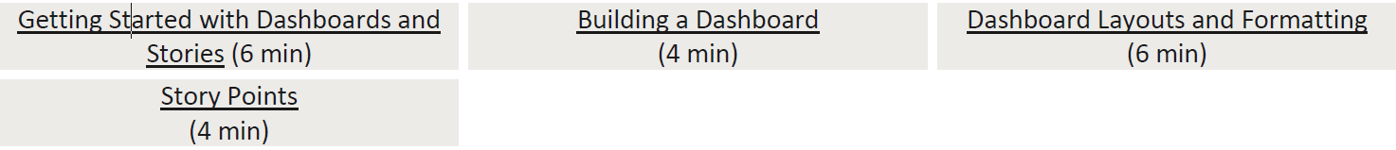

#### Tableau Interface

Data Pane: The default left pane that lists your open data sources and the dimensions and measures contained in the selected data sources. Sets and Parameters are also listed here.

Analytics Pane: Clicking the Analytics tab on the left pane will display available analyses for the data displayed on your sheet. Inapplicable analyses will be grayed out. Analyses include adding constant lines, box plots, trend lines, forecasts, and reference bands.

Marks Card: The Marks card is the tool used to create a sheet that controls most of the visual elements in a sheet. Using the Marks card, you can switch between different chart types (bar, line, symbol, filled map, and so on), change colors and sizes, add labels, change the level of detail, and edit the tool tips.

Rows and Columns Shelves: The Rows shelf and the Columns shelf is where you determine which variables will go on what axis. Put data you want displayed along the X-axis on the Columns shelf and data you want displayed on the Y-axis on the Rows shelf.

## POWER BI

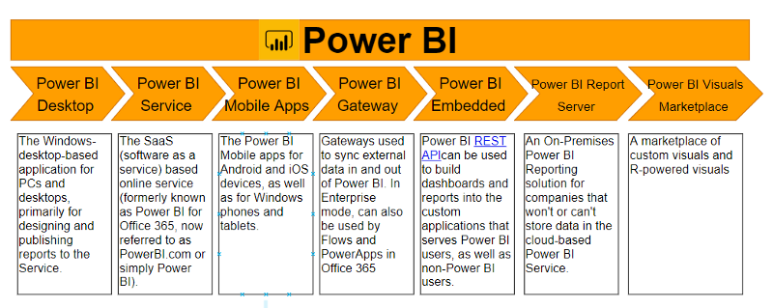

## MONGODB

##### Terminology and Concepts

The following table presents the various SQL terminology and concepts and the corresponding MongoDB terminology and concepts.

|  |  |
| --- | --- |
| SQL Terms/Concepts | MongoDB Terms/Concepts |
| database | [database](https://docs.mongodb.com/manual/reference/glossary/#term-database) |
| table | [collection](https://docs.mongodb.com/manual/reference/glossary/#term-collection) |
| row | [document](https://docs.mongodb.com/manual/reference/glossary/#term-document) or [BSON](https://docs.mongodb.com/manual/reference/glossary/#term-bson) document |
| column | [field](https://docs.mongodb.com/manual/reference/glossary/#term-field) |
| index | [index](https://docs.mongodb.com/manual/reference/glossary/#term-index) |
| table joins | [$lookup](https://docs.mongodb.com/manual/reference/operator/aggregation/lookup/#pipe._S_lookup), embedded documents |
| primary key  Specify any unique column or column combination as primary key. | [primary key](https://docs.mongodb.com/manual/reference/glossary/#term-primary-key)  In MongoDB, the primary key is automatically set to the [_id](https://docs.mongodb.com/manual/reference/glossary/#term-id) field. |
| aggregation (e.g. group by) | aggregation pipeline  See the [SQL to Aggregation Mapping Chart](https://docs.mongodb.com/manual/reference/sql-aggregation-comparison/). |
| transactions | [transactions](https://docs.mongodb.com/manual/core/transactions/)  For many scenarios, the [denormalized data model (embedded documents and arrays)](https://docs.mongodb.com/manual/core/data-model-design/#data-modeling-embedding) will continue to be optimal for your data and use cases instead of multi-document transactions. That is, for many scenarios, modeling your data appropriately will minimize the need for multi-document transactions. |

##### Executables

The following table presents some database executables and the corresponding MongoDB executables. This table is *not* meant to be exhaustive.

|  |  |  |  |  |  |
| --- | --- | --- | --- | --- | --- |
|  | MongoDB | MySQL | Oracle | Informix | DB2 |
| Database Server | [mongod](https://docs.mongodb.com/manual/reference/program/mongod/#bin.mongod) | mysqld | oracle | IDS | DB2 Server |
| Database Client | [mongo](https://docs.mongodb.com/manual/reference/program/mongo/#bin.mongo) | mysql | sqlplus | DB-Access | DB2 Client |

##### Examples

The following table presents the various SQL statements and the corresponding MongoDB statements. The examples in the table assume the following conditions:

* The SQL examples assume a table named people.
* The MongoDB examples assume a collection named people that contain documents of the following prototype:

{

_id: ObjectId("509a8fb2f3f4948bd2f983a0"),

user_id: "abc123",

age: 55,

status: 'A'

}

###### Create and Alter

The following table presents the various SQL statements related to table-level actions and the corresponding MongoDB statements.

|  |  |
| --- | --- |
| SQL Schema Statements | MongoDB Schema Statements |
| CREATE TABLE people (  id MEDIUMINT NOT NULL  AUTO_INCREMENT,  user_id Varchar(30),  age Number,  status char(1),  PRIMARY KEY (id)  ) | Implicitly created on first [insertOne()](https://docs.mongodb.com/manual/reference/method/db.collection.insertOne/#db.collection.insertOne) or [insertMany()](https://docs.mongodb.com/manual/reference/method/db.collection.insertMany/#db.collection.insertMany) operation. The primary key _id is automatically added if _id field is not specified.  db.people.insertOne( {  user_id: "abc123",  age: 55,  status: "A"  } )  However, you can also explicitly create a collection:  db.createCollection("people") |
| ALTER TABLE people  ADD join_date DATETIME | Collections do not describe or enforce the structure of its documents; i.e. there is no structural alteration at the collection level.  However, at the document level, [updateMany()](https://docs.mongodb.com/manual/reference/method/db.collection.updateMany/#db.collection.updateMany) operations can add fields to existing documents using the [$set](https://docs.mongodb.com/manual/reference/operator/update/set/#up._S_set) operator.  db.people.updateMany(  { },  { $set: { join_date: new Date() } }  ) |
| ALTER TABLE people  DROP COLUMN join_date | Collections do not describe or enforce the structure of its documents; i.e. there is no structural alteration at the collection level.  However, at the document level, [updateMany()](https://docs.mongodb.com/manual/reference/method/db.collection.updateMany/#db.collection.updateMany) operations can remove fields from documents using the [$unset](https://docs.mongodb.com/manual/reference/operator/update/unset/#up._S_unset) operator.  db.people.updateMany(  { },  { $unset: { "join_date": "" } }  ) |
| CREATE INDEX idx_user_id_asc  ON people(user_id | db.people.createIndex( { user_id: 1 } ) |
| CREATE INDEX  idx_user_id_asc_age_desc  ON people(user_id, age DESC) | db.people.createIndex( { user_id: 1, age: -1 } ) |
| DROP TABLE people | db.people.drop() |

For more information on the methods and operators used, see:

|  |  |  |
| --- | --- | --- |
| [db.collection.insertOne()](https://docs.mongodb.com/manual/reference/method/db.collection.insertOne/#db.collection.insertOne)  [db.collection.insertMany()](https://docs.mongodb.com/manual/reference/method/db.collection.insertMany/#db.collection.insertMany)  [db.createCollection()](https://docs.mongodb.com/manual/reference/method/db.createCollection/#db.createCollection) | [db.collection.updateMany()](https://docs.mongodb.com/manual/reference/method/db.collection.updateMany/#db.collection.updateMany)  [db.collection.createIndex()](https://docs.mongodb.com/manual/reference/method/db.collection.createIndex/#db.collection.createIndex)  [db.collection.drop()](https://docs.mongodb.com/manual/reference/method/db.collection.drop/#db.collection.drop) | [$set](https://docs.mongodb.com/manual/reference/operator/update/set/#up._S_set)  [$unset](https://docs.mongodb.com/manual/reference/operator/update/unset/#up._S_unset) |

See also: ⬩[Databases and Collections](https://docs.mongodb.com/manual/core/databases-and-collections/) ⬩[Documents](https://docs.mongodb.com/manual/core/document/) ⬩[Indexes](https://docs.mongodb.com/manual/indexes/) ⬩[Data Modeling Concepts](https://docs.mongodb.com/manual/core/data-models/).

###### Insert

The following table presents the various SQL statements related to inserting records into tables and the corresponding MongoDB statements.

|  |  |
| --- | --- |
| SQL INSERT Statements | MongoDB insertOne() Statements |
| INSERT INTO people(user_id,  age,  status)  VALUES ("bcd001",  45,  "A") | db.people.insertOne(  { user_id: "bcd001", age: 45, status: "A" }  ) |

For more information, see [db.collection.insertOne()](https://docs.mongodb.com/manual/reference/method/db.collection.insertOne/#db.collection.insertOne).

See also ⬩[Insert Documents](https://docs.mongodb.com/manual/tutorial/insert-documents/) ⬩[db.collection.insertMany()](https://docs.mongodb.com/manual/reference/method/db.collection.insertMany/#db.collection.insertMany) ⬩[Databases and Collections](https://docs.mongodb.com/manual/core/databases-and-collections/) ⬩[Documents](https://docs.mongodb.com/manual/core/document/)

###### Select

The following table presents the various SQL statements related to reading records from tables and the corresponding MongoDB statements. **Note:** The [find()](https://docs.mongodb.com/manual/reference/method/db.collection.find/#db.collection.find) method always includes the _id field in the returned documents unless specifically excluded through [projection](https://docs.mongodb.com/manual/tutorial/project-fields-from-query-results/#projection). Some of the SQL queries below may include an _id field to reflect this, even if the field is not included in the corresponding [find()](https://docs.mongodb.com/manual/reference/method/db.collection.find/#db.collection.find) query.

|  |  |
| --- | --- |
| SQL SELECT Statements | MongoDB find() Statements |
| SELECT *  FROM people | db.people.find() |
| SELECT id,  user_id,  status  FROM people | db.people.find(  { },  { user_id: 1, status: 1 }  ) |
| SELECT user_id, status  FROM people | db.people.find(  { },  { user_id: 1, status: 1, _id: 0 }  ) |
| SELECT *  FROM people  WHERE status = "A" | db.people.find(  { status: "A" }  ) |
| SELECT user_id, status  FROM people  WHERE status = "A" | db.people.find(  { status: "A" },  { user_id: 1, status: 1, _id: 0 }  ) |
| SELECT *  FROM people  WHERE status != "A" | db.people.find(  { status: { $ne: "A" } }  ) |
| SELECT *  FROM people  WHERE status = "A"  AND age = 50 | db.people.find(  { status: "A",  age: 50 }  ) |
| SELECT *  FROM people  WHERE status = "A"  OR age = 50 | db.people.find(  { $or: [ { status: "A" } , { age: 50 } ] }  ) |
| SELECT *  FROM people  WHERE age > 25 | db.people.find(  { age: { $gt: 25 } }  ) |
| SELECT *  FROM people  WHERE age < 25 | db.people.find(  { age: { $lt: 25 } }  ) |
| SELECT *  FROM people  WHERE age > 25  AND age <= 50 | db.people.find(  { age: { $gt: 25, $lte: 50 } }  ) |
| SELECT *  FROM people  WHERE user_id like "%bc%" | db.people.find( { user_id: /bc/ } )  -or-  db.people.find( { user_id: { $regex: /bc/ } } ) |
| SELECT *  FROM people  WHERE user_id like "bc%" | db.people.find( { user_id: /^bc/ } )  -or-  db.people.find( { user_id: { $regex: /^bc/ } } ) |
| SELECT *  FROM people  WHERE status = "A"  ORDER BY user_id ASC | db.people.find( { status: "A" } ).sort( { user_id: 1 } ) |
| SELECT *  FROM people  WHERE status = "A"  ORDER BY user_id DESC | db.people.find( { status: "A" } ).sort( { user_id: -1 } ) |
| SELECT COUNT(*)  FROM people | db.people.count()  *or*  db.people.find().count() |
| SELECT COUNT(user_id)  FROM people | db.people.count( { user_id: { $exists: true } } )  *or*  db.people.find( { user_id: { $exists: true } } ).count() |
| SELECT COUNT(*)  FROM people  WHERE age > 30 | db.people.count( { age: { $gt: 30 } } )  *or*  db.people.find( { age: { $gt: 30 } } ).count() |
| SELECT DISTINCT(status)  FROM people | db.people.aggregate( [ { $group : { _id : "$status" } } ] )  or, for distinct value sets that do not exceed the [BSON size limit](https://docs.mongodb.com/manual/reference/limits/#limit-bson-document-size)  db.people.distinct( "status" ) |
| SELECT *  FROM people  LIMIT 1 | db.people.findOne()  *or*  db.people.find().limit(1) |
| SELECT *  FROM people  LIMIT 5  SKIP 10 | db.people.find().limit(5).skip(10) |
| EXPLAIN SELECT *  FROM people  WHERE status = "A" | db.people.find( { status: "A" } ).explain() |

For more information on the methods and operators used, see

|  |  |
| --- | --- |
| [db.collection.find()](https://docs.mongodb.com/manual/reference/method/db.collection.find/#db.collection.find)  [db.collection.distinct()](https://docs.mongodb.com/manual/reference/method/db.collection.distinct/#db.collection.distinct)  [db.collection.findOne()](https://docs.mongodb.com/manual/reference/method/db.collection.findOne/#db.collection.findOne)  [limit()](https://docs.mongodb.com/manual/reference/method/cursor.limit/#cursor.limit)  [skip()](https://docs.mongodb.com/manual/reference/method/cursor.skip/#cursor.skip)  [explain()](https://docs.mongodb.com/manual/reference/method/cursor.explain/#cursor.explain)  [sort()](https://docs.mongodb.com/manual/reference/method/cursor.sort/#cursor.sort)  [count()](https://docs.mongodb.com/manual/reference/method/cursor.count/#cursor.count) | [$ne](https://docs.mongodb.com/manual/reference/operator/query/ne/#op._S_ne)  [$and](https://docs.mongodb.com/manual/reference/operator/query/and/#op._S_and)  [$or](https://docs.mongodb.com/manual/reference/operator/query/or/#op._S_or)  [$gt](https://docs.mongodb.com/manual/reference/operator/query/gt/#op._S_gt)  [$lt](https://docs.mongodb.com/manual/reference/operator/query/lt/#op._S_lt)  [$exists](https://docs.mongodb.com/manual/reference/operator/query/exists/#op._S_exists)  [$lte](https://docs.mongodb.com/manual/reference/operator/query/lte/#op._S_lte)  [$regex](https://docs.mongodb.com/manual/reference/operator/query/regex/#op._S_regex) |

See also: ⬩[Query Documents](https://docs.mongodb.com/manual/tutorial/query-documents/) ⬩[Query and Projection Operators](https://docs.mongodb.com/manual/reference/operator/query/) ⬩[mongo Shell Methods](https://docs.mongodb.com/manual/reference/method/)

###### Update Records

The following table presents the various SQL statements related to updating existing records in tables and the corresponding MongoDB statements.

|  |  |
| --- | --- |
| SQL Update Statements | MongoDB updateMany() Statements |
| UPDATE people  SET status = "C"  WHERE age > 25 | db.people.updateMany(  { age: { $gt: 25 } },  { $set: { status: "C" } }  ) |
| UPDATE people  SET age = age + 3  WHERE status = "A" | db.people.updateMany(  { status: "A" } ,  { $inc: { age: 3 } }  ) |

For more information on the method and operators used in the examples:

⬩[db.collection.updateMany()](https://docs.mongodb.com/manual/reference/method/db.collection.updateMany/#db.collection.updateMany) ⬩[$gt](https://docs.mongodb.com/manual/reference/operator/query/gt/#op._S_gt) ⬩[$set](https://docs.mongodb.com/manual/reference/operator/update/set/#up._S_set) ⬩[$inc](https://docs.mongodb.com/manual/reference/operator/update/inc/#up._S_inc) See also: ⬩[Update Documents](https://docs.mongodb.com/manual/tutorial/update-documents/) ⬩[Update Operators](https://docs.mongodb.com/manual/reference/operator/update/) ⬩[db.collection.updateOne()](https://docs.mongodb.com/manual/reference/method/db.collection.updateOne/#db.collection.updateOne) ⬩[db.collection.replaceOne()](https://docs.mongodb.com/manual/reference/method/db.collection.replaceOne/#db.collection.replaceOne)

###### Delete Records

The following table presents the various SQL statements related to deleting records from tables and the corresponding MongoDB statements.

|  |  |
| --- | --- |
| SQL Delete Statements | MongoDB deleteMany() Statements |
| DELETE FROM people  WHERE status = "D" | db.people.deleteMany( { status: "D" } ) |
| DELETE FROM people | db.people.deleteMany({}) |

For more information, see [db.collection.deleteMany()](https://docs.mongodb.com/manual/reference/method/db.collection.deleteMany/#db.collection.deleteMany). See also: ⬩[Delete Documents](https://docs.mongodb.com/manual/tutorial/remove-documents/) ⬩

[db.collection.deleteOne()](https://docs.mongodb.com/manual/reference/method/db.collection.deleteOne/#db.collection.deleteOne)

## Microservices

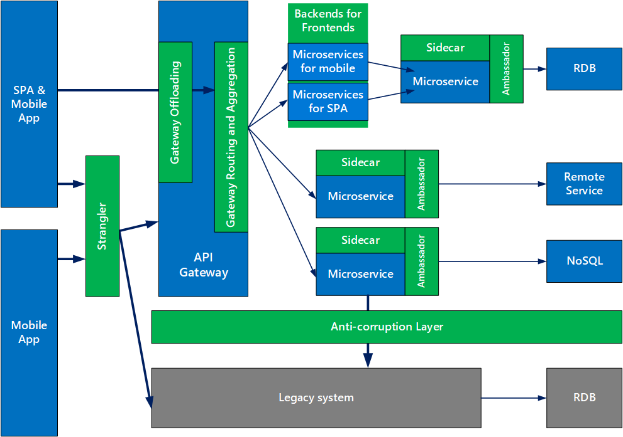

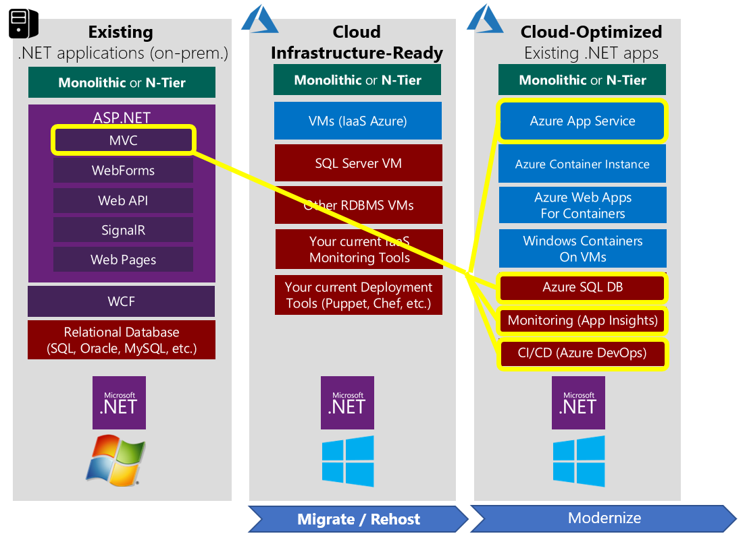

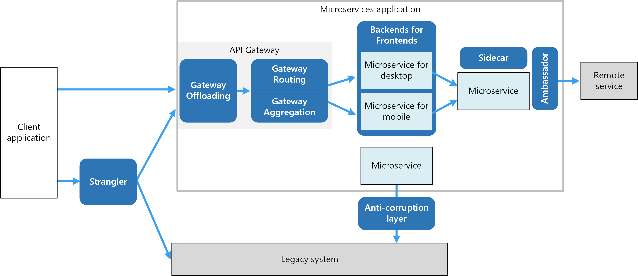

* ⬩[**Ambassador**](https://docs.microsoft.com/azure/architecture/patterns/ambassador) to offload common client connectivity tasks such as monitoring, logging, routing, and security (such as TLS) in a language agnostic way ⬩[**Anti-corruption layer**](https://docs.microsoft.com/azure/architecture/patterns/anti-corruption-layer) implements a façade between new and legacy applications, to ensure that the design of a new application is not limited by dependencies on legacy systems ⬩[**Backends for Front-ends**](https://docs.microsoft.com/azure/architecture/patterns/backends-for-frontends) creates separate backend services for different types of clients (desktop, mobile) ⇨ A single backend service doesn’t need to handle the conflicting requirements of various client types. This pattern can help keep each microservice simple, by separating client-specific concerns ⬩[**Bulkhead**](https://docs.microsoft.com/azure/architecture/patterns/bulkhead) isolates critical resources (connection pool, memory, CPU) for each workload or service. A single workload (or service) can’t consume all of the resources, starving others. This pattern increases the resiliency of the system by preventing cascading failures caused by one service ⬩[**Gateway Aggregation**](https://docs.microsoft.com/azure/architecture/patterns/gateway-aggregation) aggregates requests to multiple individual microservices into a single request, reducing chattiness between consumers and services ⬩[**Gateway Offloading**](https://docs.microsoft.com/azure/architecture/patterns/gateway-offloading) enables each microservice to offload shared service functionality, such as the use of SSL certificates, to an API gateway ⬩[**Gateway Routing**](https://docs.microsoft.com/azure/architecture/patterns/gateway-routing) routes requests to multiple microservices using a single endpoint, so that consumers don't need to manage many separate endpoints ⬩[**Sidecar**](https://docs.microsoft.com/azure/architecture/patterns/sidecar) deploys helper components of an application as a separate container or process to provide isolation and encapsulation ⬩[**Strangler**](https://docs.microsoft.com/azure/architecture/patterns/strangler) supports incremental migration by gradually replacing specific pieces of functionality with new services.

#### API

#### 12 FACTORS

Cloud-friendly applications embrace elastic scalability, ephemeral filesystems, statelessness, and treating everything as a service ⇨ Can scale and deploy rapidly ⬩**Codebase** One codebase tracked in revision control, many deploys ⬩**Dependencies**. Explicitly declare and isolate dependencies ⬩**Configuration**: Store configuration in the environment ⬩**Backing Services**: Treat backing services as attached resources ⬩**Build, release, run:** Separate build and run stages ⬩**Processes**: Execute app as one or more stateless processes ⬩**Port binding:** Export services via port binding ⬩**Concurrency**: Scale out via the process model

⬩**Disposability**: Maximize robustness with fast startup and graceful shutdown ⬩**Dev/prod parity:** Keep development, staging, and production as similar as possible ⬩**Logs**: Treat logs as event streams ⬩**Admin processes**: Run admin/management tasks as one-off processes

#### REST

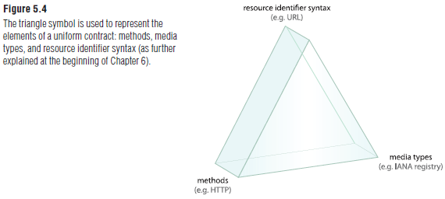REST constraints are design rules that are applied to establish the distinct characteristics

of the REST architectural style. Each constraint is a pre-determined design decision that can have both positive and negative impacts. The intent is for the positives of each constraint to balance out the negatives to produce an overall architecture that resembles the best features of the Web. Formal REST constraints: ⬩**Client-Server** {393} requires that a service offer one or more capabilities and listen for requests on these capabilities. A consumer invokes a capability by sending the corresponding request message, and the service either rejects the request or performs the requested task before sending a response message back to the consumer. Exceptions that prevent the task from proceeding are raised back to the consumer, and the consumer is responsible for taking corrective action ⬩**Stateless** {395} The communication between service consumer (client) and service (server) must be stateless between requests. This means that each request from a service consumer should contain all the necessary information for the service to understand the meaning of the request, and all session state data should then be returned to the service consumer at the end of each request. Statelessness is one of the primary influences over service contract design in REST-style architecture. It imposes significant restrictions on the kinds of communication allowed between services and their consumers in order to achieve its design goals. The application of the Cache {398} and Layered System {404} constraints helps to compensate for limitations resulting from Stateless {395} ⬩**Cache** {398} Response messages from the service to its consumers are explicitly labeled as cacheable or non-cacheable. This way, the service, the consumer, or one of the intermediary middleware components can cache the response for reuse in later requests. The Cache {398} constraint builds upon Client-Server {393} and Stateless {395} with a requirement that responses are implicitly or explicitly labeled as cacheable or noncacheable. Requests are passed through a cache component, which may reuse previous responses to partially or completely eliminate some interactions over the network. This form of elimination can improve efficiency and scalability, and can further improve user-perceived performance by reducing the average latency during a series of interactions. However, a common reason for incorporating caching as a native part of a REST architecture is as a counterbalance to some of the negative impacts of applying the Stateless {395} constraint ⬩**Interface/Uniform Contract** {400} The Interface {400} constraint (also known as “Uniform Interface”) states that all services and service consumers within a REST-compliant architecture must share a single, overarching technical interface. As the primary constraint that distinguishes REST from other architecture types, Interface {400} is generally applied using the methods and media types provided by HTTP and other Internet standards ⬩**Code-On-Demand** {407} This optional constraint is primarily intended to allow logic within clients (such as Web browsers) to be updated independently from server-side logic. Code-On-Demand {407} typically relies on the use of Web-based technologies, such as Web browser plug-ins, applets, or client-side scripting languages (i.e. JavaScript). Code-On-Demand {407} can further be applied to services and service consumers. For example, a service can be designed to dynamically defer portions of logic to service consumer programs. For example, this type of functionality can be used in support of Stateless {395}, which dictates when session state should be deferred back to the service consumer. Code-On-Demand {407} can also build upon this by further deferring the processing effort. This approach may be justifiable when service logic can be executed by the consumer more efficiently or effectively

#### DOCKER

Docker = platform for packaging, distributing, and running applications. Allows you to package your application together with its whole environment (libraries that the app requires or files usually available on the filesystem of an installed operating system). Docker makes it possible to transfer this package to a central repository from which it can then be transferred to any computer running Docker and executed there. 3 concepts: ➊**Images:** Docker-based container image is something you package your application and its environment into. It contains the filesystem that will be available to the application and other metadata, such as the path to the executable that should be executed when the image is run. ➋**Registries**: A Docker Registry is a repository that stores your Docker images and facilitates easy sharing of those images between different people and computers. When you build your image, you can either run it on the computer you’ve built it on, or you can push (upload) the image to a registry and then pull (download) it on another computer and run it there. Certain registries are public, allowing anyone to pull images from it, while others are private, only accessible

to certain people or machines. ➌**Containers**: Docker-based container is a regular Linux container created from a Docker-based container image. A running container is a process running on the host running Docker, but it’s completely isolated from both the host and all

other processes running on it. The process is also resource-constrained, meaning it can only access and use the amount of resources (CPU, RAM, and so on) that are allocated to it.

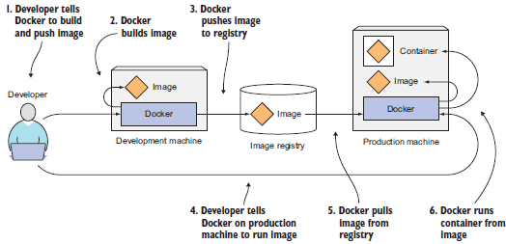

#### KUBERNETES

Kubernetes is a software system that allows you to easily deploy and manage containerized

applications on top of it. It relies on the features of Linux containers to run heterogeneous

applications without having to know any internal details of these applications and without having to manually deploy these applications on each host. Because these apps run in containers, they don’t affect other apps running on the same server, which is critical when you run applications for completely different organizations on the same hardware. Kubernetes enables you to run your software applications on thousands of computer nodes as if all those nodes were a single, enormous computer. It abstracts away the underlying infrastructure and, by doing so, simplifies development, deployment, and management for both development and the operations teams. Deploying applications through Kubernetes is always the same, whether your cluster contains only a couple of nodes or thousands of them. The size of the cluster makes no difference at all. Additional cluster nodes simply represent an additional amount of resources available to deployed apps.

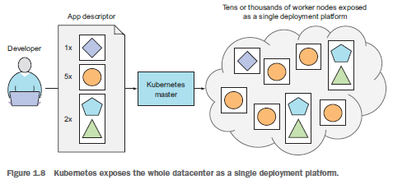

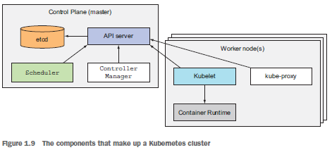

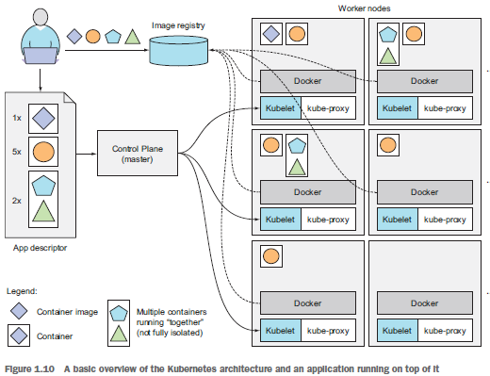

## PYTHON

#### LUIGI

#### DASK

#### PANDAS

#### SQL ALCHEMY

## R

#### Data Structure

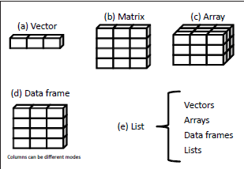

## JAVASCRIPT

## SCIKIT-LEARN

## TENSORFLOW

## PYTORCH

## MACHINE LEARNING

**⬩Regression questions**: ‘How much’ and ‘how many’. For example, how much will my car be worth in two years? ⬩**Classification questions**: such as ‘Type of object’. For example, what to class does this object belong? ⬩**Clustering or grouping questions**. For example, what are the different clusters for this particular set of objects? ⬩**Abnormality detection questions**. For example, is this object abnormal based on what is defined as normal?

#### Regression

#### Boost

#### Deep Learning

## Feature Engineering

➊**Resampling Imbalanced Data**: Balanced Accuracy, Precision-Recall Curves, F1-score, SMOTE (Synthetic Minority Oversampling Technique) ➋**Creating New Features**: DFS (Deep Feature Synthesis) ➌**Handling Missing Values**: Iterative Imputer (R imputation packages missForest, mi, mice, etc.) ➍**Outlier Detection**: Isolation Forest

# EXHIBIT

## SOX Application Inventory

|  |  |  |  |  |  |  |  |  |  |  |  |  |  |  |  |
| --- | --- | --- | --- | --- | --- | --- | --- | --- | --- | --- | --- | --- | --- | --- | --- |
|  |  |  |  |  |  |  |  |  | **Risk Ranking** | | | |  |  |  |
| **PRC Assessment** | **Mega Process** | **Process** | **Sub-Process** | **System In-Scope For:** | **GEAR Application ID** | **Application & Instance Name** | **Application Description per FCU** | **Estimated Total Amount Processed (Annually in USD)** | **Impact (High, Medium, Low)** | **Complexity (High, Medium, Low)** | **Integrity (High, Medium, Low)** | **Overall Risk Rating (High, Medium, Low)** | **SOX/MAR Scoping Category for IT Testing (Full Scope, Limited Scope, No Planned Coverage; N/A - Non-SOX)** | **IT Testing Coverage for Limited Scope Applications** | **Scoping Comments** |
| Global Operations - Dublin Operations;  Global Operations - Reference Data;  Global Operations - Middle Office;  I&FS Finance - IA NY | Investments Portfolio | Investment Management Operations - Back Office;  Investment Accounting | Trade Capture; Reference Data Maintenance;  BU Submissions | SOX/MAR |  | Clearwater System | Clearwater System is a vendor hosted software package used as a sub ledger for fix income and equity investments and includes a data management and reconciliation tools. | $300,000,000,000 | High | High | High | High | Partial Year Coverage - Went Live Effective 6/23/18 due to migration from PAM. | - User Access - Change Management - Reliance on SOC 1 for ITGC controls. |  |
| I&FS Finance - GRE Investments | Investments Portfolio | Investment Accounting | Valuation and Impairment | SOX/MAR | 3607 | Argus Enterprise | ARGUS Enterprise is designed for companies and financial institutions that need to project the performance of their assets throughout the life-cycle of the investment. It is used by AIG Global Real Estate in the valuation process for real estate investments. | $9,100,000,000 | Medium | Medium | Medium | Medium | Full Scope |  |  |
| I&FS Finance - IA LA | Investments Portfolio | Investment Accounting | Settlement | SOX | 3337 | CLCS (Construction Loan Control System) | Affordable Housing uses CLCS for setting up, monitoring, servicing, invoicing, and reporting loan information (such as loan balances, interest accruals, etc.). | $51,000,000 | Medium | High | Medium | Medium | Full Scope |  |  |
| I&FS Finance - Cap Corp | Accounting & Financial Reporting | Financial Close | GL Account Reconciliation;  BU Submissions | SOX/MAR | 366 | SAP PEC | AIG Investments instance of SAP general ledger. | $0 | Medium | Medium | Medium | Medium | Full Scope |  |  |
| I&FS Finance - AIGFP | Accounting & Financial Reporting | Financial Close | GL Account Reconciliation;  BU Submissions | SOX/MAR | 149 | SAP PRD - FP | AIGFP instance of SAP general ledger. | $200,000,000,000 | Medium | Medium | Medium | Medium | Full Scope |  |  |
| AIGI Front Office - Structured Products NY;  AIGI Front Office - Structured Products London | Investments Portfolio | Investment Management Operations - Front Office | Valuation and Impairment | SOX/MAR | 4128 | GDA Generic Document Approval | Appian Workflow tool -GDA Generic Document Approval is Appian work flow tool which is used to faciliate the approval of documents. | N/A- no relevant dollar value as this is a workflow tool for document approval. | Low | Low | Medium | Medium | Limited Scope | - User Access - Change Management |  |
| AIG Treasury - CMO Houston | Treasury Operations | Cash Management Operations | Payment Processing | SOX/MAR | 3587 | Appian - MWIRE (Manual Wire Requests) | Appian workflow tool used to process wire transfer payments. It automates wire transfer requestor submissions, payment approvals and uploads wire payments to OpenLink (treasury management system) for release. | 19,500,000,000 | Medium | Medium | Low | Medium | Limited Scope | - User Access - Change Management |  |
| I&FS Finance - IVFA | Investments Portfolio | Investment Management Operations - Other | Valuation and Impairment | SOX/MAR | 3304 | Risk Watch (Algorithmics) | Application developed by Algorithmics, used by IVFA for AIG parent and credit securities valuation/validation. The application Risk Watch is part of the Algo/Alogrithmics system | $335,500,000,000 | Low | Medium | Low | Medium | Limited Scope | - User Access - Change Management |  |
| Procurement - Ariba | Other General Operating Expenses | Other General Operating Expenses | Accounts Payable | SOX/MAR | 3347 | Ariba Procure to Pay On Demand (Ariba Spend Management) | Ariba ia a web-based suite of applications that is used firm-wide to manage the purchase of goods and services (i.e. office supplies, computers, and software). There are three main applications within this system: 1: Sourcing (RFP & quotes) 2. Contracts (storage of contracts, vendor profiles) and 3. Procurement (procure goods & services). Only the Procurement application of Ariba is in scope for SOX. | $440,000,000 | Medium | Medium | Medium | Medium | Limited Scope | User Access | This vendor application is only in-scope for SOX covering functionality for initiating office supply purchases and approving invoices for payment. Functionality can not be changed by AIG. AIG personnel are responsible for granting access to users. |
| ITGC | ITGC | ITGC | ITGC | SOX/MAR | 3271 | Autosys | AutoSys is a job scheduling tool used for uploads to various applications. | $0 |  |  |  |  | IT Tool |  | IT Tool and scoping assessment to be determined by IT SOX Lead |
| AIG Treasury - CMO Houston;  Global Operations - GCM Operations & Collateral Management Wilton | Treasury Operations;   Investments Portfolio | Cash Management Operations;  Investment Management Operations - Back Office | Payment Processing | SOX/MAR | 3450 | BizTalk 2013 | BizTalk is used for duplicate payment checks and for uploading wire transfer payments to Swift to facilitate transmission to banks for release. | $0 | Medium | Medium | Medium | Medium | Full Scope |  |  |
| AIGI Front Office- Public Fixed Income NY | Investments Portfolio | Investment Management Operations - Front Office | Trade Capture | SOX/MAR | 295 | Bloomberg - AIM | Bloomberg is a vendor software system that provides an electronic trading platform and access to real-time financial markets data. | $107 billion | Low | Low | Low | Low | Limited Scope | - User Access - Change Management |  |
| AIGI Front Office - Affordable Housing | Investments Portfolio | Investment Management Operations - Front Office | Valuation and Impairment | SOX/MAR | 3706 | Cash Flow Model (AHP) | Cash Flow Model is an Excel fronted Oracle based model that provides estimates of future Cash Flows of Affordable Housing Real Estate assets.  This system is critical to the valuation of the affordable housing papartnerships and also is used for calculating reserves and non-controlling interests related to the partnerships, all of which have a material impact to the financial statements | $5,600,000,000 | Medium | High | Medium | Medium | Full Scope |  |  |
| AIG Treasury - CMO Houston | Treasury Operations | Cash Management Operations | Payment Processing | SOX/MAR | 558 | Central Disbursement Control System (CDCS) | CDCS is a centralized mainframe processing system for check and ACH payment requests emanating from various source systems across AIG domestic and Canadian businesses. | $18,871,418,000 | Medium | Medium | Medium | Medium | Full Scope |  |  |
| I&FS Finance - IVFA | Investments Portfolio | Investment Management Operations - Other | Valuation and Impairment | SOX/MAR | 190 | CDPM2 | CDPM2 is an internally developed system used to report and track notional, population and other trade details for valuation purposes on the AIGFP Super Senior Portfolio. | $2,500,000,000 | Low | Low | Low | Low | Limited Scope | User Access |  |
| AIG Treasury - CMO Houston | Treasury Operations | Cash Management Operations | Payment Processing | SOX/MAR | 656 | Corporate Treasury- CPCS | Centralized processing of international payments. | $2,400,212,845.00 | Medium | Medium | Medium | Medium | Full Scope |  |  |
| AIG Treasury - CMO Houston | Treasury Operations | Cash Management Operations | Payment Processing | **SOX/MAR** | **509** | **Corporate Treasury - CPCS Error Recyle** | **Centralized processing of international payments.** | $2,400,212,845.00 | Medium | Medium | Medium | Medium | Full Scope |  |  |
| AIG Treasury - CMO Houston | Treasury Operations | Bank Administration | Bank Account Maintenance;  Authorized Signatories Maintenance | SOX/MAR | 500 | ORD/Trust (Wall Street Systems) | Data repository and reporting tool used to maintain inventory of bank accounts, as well generating cash pool fund position, bank position and cash flows. | N/A-reporting only | Medium | Medium | Medium | Medium | Limited Scope | User Access | Vendor application used to maintain listing of bank accounts and authorized signers. |
| I&FS Finance - IA NY;  Core Reporting - DQA;  Global Operations - Middle Office | Investments Portfolio | Investment Accounting;  Investment Management Operations - Other;  Investment Management Operations - Back Office | GL Account Reconciliation;   BU Submissions;  Sub-Ledger Reconciliation | SOX/MAR | 3463 | Investment Data Reporting (IDR) (Warehouse) | Data warehouse which contains Investments data used for financial and management Reporting. This application includes IDR Adjustment Module, IDR Maintenance, and future IDR data utility tools. | $15,000,000,000 | High | High | Medium | High | Full Scope |  |  |
| I&FS Finance - IA NY;  Global Operations - Reference Data | Investments Portfolio | Investment Accounting;  Investment Management Operations - Back Office | Reference Data Maintenance Valuation and Impairment | SOX/MAR | 314 | FAS157 -IDR | FAS 157 is an Internally developed application that provides reporting for security leveling by position based on pre-determined rules and observable / unobservable markets. | GR - $150,000,000 JH - TBD - pending 2017 data from process owner. | Medium | Medium | Medium | Medium | Full Scope |  |  |
| Procurement - Ariba | Other General Operating Expenses | Other General Operating Expenses | Accounts Payable | SOX/MAR | 45 | Fieldglass | Fieldglass is a web-based application that helps facilitate the contingent worker engagement process from start to finish (e.g. manage consultants from procurement to invoicing and payment). | $660,000,000 | Medium | Medium | Medium | Medium | Limited Scope | User Access | This vendor application is only in-scope for SOX covering functionality for procuring contingent/consulting resources and approving invoices for payment. Functionality can not be changed by AIG. AIG personnel are responsible for granting access to users. |
| AIGI Front Office - Private Placements | Investments Portfolio | Investment Management Operations - Front Office | Valuation and Impairment | SOX/MAR | 308 | Private Placement Pricing -PPV- | Internal program that is used for pricing private placement securities. It stores prices received from brokers and uses internally generated credit (expected loss) ratings, broker credit spreads and treasury rates to calculate discount rates (i.e. yields) used for discounted cashflow pricing. The yields are uploaded to PAM and prices are calculated in PAM (based on the discounting of cash flows. | $212,000,000,000 | High | High | Medium | High | Full Scope |  |  |
| I&FS Finance - IVFA;   AIGI Front Office - Structured Products London | Investments Portfolio | Investment Management Operations - Other;  Investment Management Operations - Front Office | Valuation and Impairment | SOX/MAR | 255 | STAR / WalProc | Internally developed system utilizing an Oracle relational database with a front-end application developed specifically for the surveillance processing and reporting for structured securities. | $826,994,286 | Medium | Medium | Medium | Medium | Full Scope |  |  |
| I&FS Finance - GRE Accounting | Investments Portfolio | Investment Accounting | Valuation and Impairment;  GL Account Reconciliation;  BU Submissions | SOX/MAR | 327 | Investran GRE | Investran GRE is the sub-ledger for real estate investments. | $200,000,000 | Medium | Medium | Medium | Medium | Full Scope |  |  |
| I&FS Finance - IA NY | Investments Portfolio | Investment Accounting | Valuation and Impairment;  GL Account Reconciliation;  BU Submissions | SOX/MAR | 328 | Investran IA | Investran IA is the sub-ledger for alternative Investments (i.e. private equity partnerships and hedge funds). | $22,000,000,000 | Medium | Medium | Medium | Medium | Full Scope |  |  |
| I&FS Finance - DAG;  I&FS Finance - AIGFP;  I&FS Finance - GCM Trade Review;  Global Operations - U.S. Operations;  Global Operations - GCM Operations & Collateral;  Management Wilton AIGI Front Office - GCM | Investments Portfolio | Derivative Accounting;  Financial Close;  Investment Management Operations - Other;  Investment Management Operations - Back Office;  Investment Management Operations - Front Office | Authorization and Execution;  Trade Capture;  Reference Data Maintenance;  Sub-Ledger Reconciliation;  GL Account Reconciliation | SOX/MAR | 220 | JAVAH | JAVAH is the subledger for derivatives, issued debt, and short term investments. | GR - $17,000,000,000 JH - $200,000,000,000 | High | High | High | High | Full Scope |  |  |
| AIGI Front Office - CML Houston;  AIGI Front Office - CML LA;  AIGI Front Office - CML New York;  Global Operations - CML Servicing | Investments Portfolio | Investment Management Operations - Front Office  Investment Management Operations - Back Office | Valuation and Impairment  Trade Capture  Sub-Ledger Reconciliation | SOX/MAR | 330 | Loan Management System (LMS) | Loan Management System (LMS) is the subledger for commercial mortgage loans. | GR - $12,600,000 JH - $30,000,000,000 | Medium | Medium | Medium | Medium | Full Scope |  |  |
| I&FS Finance - IA LA | Investments Portfolio | Investment Accounting | Valuation and Impairment | SOX/MAR | 3316 | Monthly Operating Reporting System | MORS automates the processing of monthly financials on the underlying properties of the affordable housing partnerships by collecting that data directly from property management companies. Data is loaded into a central database via an import application that accepts various types of file formats. The central database feeds the MOR Report/Interface where analysts can view summarized and detailed monthly data. A multitude of reports, such as the Occupancy Trending Report, are readily generated from MORS. | $450,000,000 | Medium | High | High | High | Full Scope |  |  |
| AIG Treasury - CMO Houston | Treasury Operations | Cash Management Operations | Payment Processing | SOX/MAR | 3616 | Corporate Treasury - OpenLink Extension | OLE is a web-based application that supports the OpenLink (treasury management) system. The reporting functionality in OLE is used for Treasury Operations SOX processes.. | N/A-reporting only | Medium | Medium | Medium | Medium | Limited Scope | - User Access - Change Management | Reporting and interface tool for data in OpenLink |
| I&FS Finance - GCM Trade Review;  Global Operations - U.S. Operations | Investments Portfolio | Investment Management Operations - Other;  Investment Management Operations - Back Office | Trade Capture | SOX | 271 | Traded Notebook | Operations workflow tool used to log any changes to positions recorded in Javah. | N/A- Not used to process derivatives. | Medium | Medium | Medium | Medium | Full Scope |  |  |
| Investments Analytics | Investments Portfolio | Investment Management Operations - Other | Valuation and Impairment | SOX/MAR | 354 | Polypaths | PolyPaths is a vendor analytic platform for structured products used in cash flow forecasting. | 212,000,000,000 | Medium | Medium | Medium | Medium | Full Scope |  |  |
| Global Operations - Dublin Operations | Investments Portfolio | Investment Management Operations - Back Office | Trade Capture | SOX/MAR | 353 | Appian - Portfolio Master File (PMF) Maintenance | This workflow tool is used for faciliating the requests for creating/modifying new/existing accounts in Clearwater system and IDR Data Pub. | NA- no relevant dollar value as the system relates to accounting treatments at Portfolio level. | Medium | Low | Medium | Medium | Limited Scope | - User Access - Change Management |  |
| Global Operations - U.S. Operations | Investments Portfolio | Investment Management Operations - Back Office | Reference Data Maintenance | SOX/MAR | 229 | PROF | PROF is used in Pricing rules and Rate setting including interest rate and exchange rate to help determine the option exercising decision. It feeds into JAVAH. | $0- Dollar amount not available | Medium | Medium | Medium | Medium | Full Scope |  |  |
| ITGC |  | ITGC |  | SOX/MAR | 363 | Re-Certification Management System (RCMS) | RCMS is a work flow tool used to manage the user ID life-cycle for the AIG Investment network and applications. RCMS is used to request, approve, and assign access to the Investments network domain and AIG Investment applications. Likewise, RCMS is used to request and approve the removal of user access. RCMS is also lso used to recertify access to AIG Investment applications and share groups. This pplication retains all access requests and approvals for audit trail purposes. | N/A |  |  |  |  | IT Tool |  | IT tool and scoping assessment to be determined by IT SOX Lead |
| I&FS Finance - IA LA | Investments Portfolio | Investment Accounting | Valuation and Impairment | SOX/MAR | 3338 | Infostore | Repository for AH Partnership financial statements, contracts, and other legal documentation | N/A | Low | Low | Medium | Low | Limited Scope | User Access |  |
| Global Operations - GCM Operations & Collateral Management Wilton | Investments Portfolio | Investment Management Operations - Back Office | Settlement Sub-Ledger Reconciliation | SOX/MAR | 249 | SACM | SACM receives cash flows from JAVAH and settlement instructions from the Clients Database, which it aggregates into payments, including applying counterparty netting rules. SACM feeds payments to Biztalk for duplicate payment checks and then payments flow to Swift to facilitate transmission to banks for release. SACM also is used for automated cash reconciliations with banks. | $800Billion | High | High | High | High | Full Scope |  |  |
| I&FS Finance - Cap Corp;  Global Operations - US Operations | Accounting & Financial Reporting;  Investments Portfolio | Financial Close;  Investment Management Operations - Back Office | Sub-Ledger Reconciliation | SOX/MAR | 4967 | MARS/ALBA | Sub-Ledger for ALBA reinsurance investments | $16,000,000 | Low | Medium | Medium | Low | Limited Scope | - User Access - Change Management |  |
| AIG Treasury - CMO Houston;  Global Operations - GCM Operations & Collateral Management Wilton | Treasury Operations;  Investments Portfolio | Cash Management Operations;  Investment Management Operations - Back Office | Settlement Payment Processing | SOX/MAR | 137 | Swift | SWIFT is a messaging network that is used to securely transmit information and instructions through a standardized system of codes. It is used for transmitting settlement instructions for wire transfer payments, securities transactions and derivatives transactions. | $0- Dollar amount not available | Medium | Low | Medium | Medium | Limited Scope | - User Access - Change Management |  |
| Global Operations - U.S. Operations;  Global Operations - GCM Operations & Collateral Management Wilton | Investments Portfolio | Investment Management Operations - Back Office | Collateral Management | SOX/MAR | 194 | Clients | The Clients database is an Oracle based application used to house client information including but not limited to Master Agreements, Payment Instructions (bank account, routing number, address and contract terms), and Credit Terms. The SACM, SCA and Credit Exposure Viewer applications pull counterparty info from this application. | N/A- This is a database that does not store financial data. | Medium | Medium | Medium | Medium | Full Scope |  |  |
| AIGI Front Office - Structured Products NY;  AIGI Front Office - CML Houston | Investments Portfolio | Investment Management Operations - Front Office;  Investment Management Operations - Front Office | Valuation and Impairment | SOX/MAR | 4990 | CoStar Compass | The CoStar Compass credit model forecasts the default behavior of the borrowers. This model is used to value the CML investments and calculate analytics which include expected loss. | JM - $20,000,000,000 (CML Only) CY - $12,334,000,000 (CMBS) | Medium | Medium | Medium | Medium | Full Scope |  |  |
| I&FS Finance - AIGFP | Accounting & Financial Reporting | Financial Close | GL Account Reconciliation | SOX/MAR | 198 | CVA | The Credit Valuation Adjustment (CVA) system is used to calculate an adjustment to the valuations for deriative and liability portfolios. | $0 | Medium | Medium | Medium | Medium | Full Scope |  |  |
| Procurement - Ariba;  Procurement - Fieldglass;  Procurement - AP | Other General Operating Expenses | Other General Operating Expenses | Accounts Payable | SOX/MAR | 4891 | Delegation of Authority (DOA) | The Delegation of Authority application standardizes approval authority limits and approval flows for the company. All approval limits are based on job grade and DOA feeds the limits to payment systems (i.e. Ariba, Fieldglass, etc.) and ensures standardization across all payment platforms. | N/A-approval limits | Low | Low | Medium | Medium | Limited Scope | - User Access - Change Management | System maintains payment authoization limits for approving GOE. There is an automated feed of authorization limits to Ariba & Fieldglass and manual updates to SAP EP1. |
| Global Operations - GCM Operations & Collateral Management Wilton | Investments Portfolio | Investment Management Operations - Back Office | Sub-Ledger Reconciliation | SOX/MAR | 203 | DTDF | The due to/from application tracks differences in expected cash payments and receipts from the SACM automated cash reconciliation tool. | N/A | Medium | Low | Medium | Medium | Limited Scope | - User Access - Change Management |  |
| AIGI Front Office - Private Placements | Investments Portfolio | Investment Management Operations - Front Office | Valuation and Impairment | SOX/MAR | 557 | Risk Entity Manager (REM) | The Risk Entity Manager (REM) is the AIG credit risk management system for managing risk limits, and other credit related attributes. The application is used by the Private Placements group to maintain and monitor internally assigned security credit (i.e. expected loss) ratings used in the matrix pricing process. | $10,000,000,000 | Medium | Medium | Medium | Medium | Limited Scope | - User Access - Change Management | Application is only relied on for expecdited loss ratings used in Private Placement matrix pricing |
| Global Operations - GCM Operations & Collateral Management Wilton | Investments Portfolio | Investment Management Operations - Back Office | Collateral Management | SOX/MAR | 251 | SCA | The summary collateral application (“SCA”) is used to monitor credit exposures between counterparties and AIGFP. SCA has a built in workflow for the collateral management process including approvals for collateral calls. The underlying ORACLE database receives data from other internal systems including Javah for daily trade valuations and Clients Database for collateral haircut information. | $0- Dollar amount not available | Medium | Medium | Medium | Medium | Full Scope |  |  |
| I&FS Finance - GCM Trade Review | Investments Portfolio | Investment Management Operations - Other | Trade Capture | SOX/MAR | 273 | TRS (Trade Review System) | The Trade Review system documents the process of validating accuracy of trade entry. It keeps track of trades that pass and fail the transaction review process. This application pulls information from JAVAH used in Trade review. Based on the logic built into this application, some trades are approved automatically based on meeting certain criteria. Other trades require manual approval. | N/A- Dollar amounts are not processed and does not feed th G/L. | High | Low | Medium | Medium | Full Scope |  |  |
| AIG Treasury - Interco Loans | Treasury Operations | Intercompany | Intercompany Loans | MAR Only | 289 | Appian - Intercompany Funding Request Process (ICFG) | This is a workflow tool for corporate entities to request intercompany loans. The AIG Intercompany Lending Policy outlines the intercompany lending process and approval thresholds for each category. | N/A. workflow tool for approvals only | Low | Low | Medium | Low | Limited Scope | - User Access - Change Management |  |
| AIG Investments Legal - GCM | Investments Portfolio | Investment Management Operations - Other | Confirmation | SOX/MAR | 4220 | Open Confirm Tracking System | This system is used to track the follow-up on open derivatives confirmations | N/A- This is a management reporting application | Low | Low | Low | Low | Limited Scope | User Access |  |
| AIG Treasury - CMO Houston;  Global Operations - Reference Data | Treasury Operations;  Investments Portfolio | Cash Management Operations;  Investment Management Operations - Back Office | Reference Data Maintenance Payment Processing | SOX/MAR | 3312 | OpenLink | Treasury Management System - An intergated vendor system use by AIG Treasury in the management of Pool Accounts and processing wire transfer payments. | 40,800,000,000 | Medium | Medium | Medium | Medium | Full Scope |  |  |
| ITGC |  | ITGC |  | SOX/MAR | 289 | Appian Application Work Flow Apps | Workflow application used to develop individual work flow tools. Individual Appian workflows are also in scope. | $10,000,000,000 | Medium | Low | Medium | Medium | Limited Scope | - User Access - Change Management | This is the Appian application used to develop the individual Appian workflow tools |
| Global Operations - GCM Operations & Collateral Management Wilton | Investments Portfolio | Investment Management Operations - Back Office | Settlement | SOX/MAR | 3399 | Citibank (CitiDirect) for Securities (AIGFPC) | Electronic banking system (EBS) used to facilitate securities settlements for AIGFP (Co #466). All settlements are released to this EBS via SACM. | $0 | Medium | Low | Medium | Medium | Limited Scope | - User Access  - Reliance on SOC 1 for appropriate change management control process. | Bank maintained EBS with wire payment capability. Non-IT testing of critical functionality requiring two separate user accounts to execute a wire transfer. |
| Global Operations - GCM Operations & Collateral Management Wilton | Investments Portfolio | Investment Management Operations - Back Office | Settlement | SOX/MAR | 143 | BNYM-Workbench/Inform (CRWBAIH [i040362]) - Trading/Investment | Electronic Banking System (EBS) - Trading and Investements | $0- Dollar amount not available | Medium | Low | Medium | Medium | Limited Scope | - User Access  - Reliance on SOC 1 for appropriate change management control process. | Bank maintained EBS with wire payment capability. Non-IT testing of critical functionality requiring two separate user accounts to execute a wire transfer. |
| Global Operations - Dublin Operations | Investments Portfolio | Investment Management Operations - Back Office | Settlement | SOX/MAR | 4240 | BONY Workbench - Inform -CRWBGLI | Electronic Banking System (EBS) - Trading and Investements | CY - $100MM+ | Medium | Low | Medium | Medium | Limited Scope | - User Access  - Reliance on SOC 1 for appropriate change management control process. | Bank maintained EBS with wire payment capability. Non-IT testing of critical functionality requiring two separate user accounts to execute a wire transfer. |
| Global Operations - Dublin Operations | Investments Portfolio | Investment Management Operations - Back Office | Settlement | SOX/MAR | 4582 | State Street Bank - AIG Dublin SSCM - 13435937 | Electronic Banking System (EBS) - Used for settlement of investment transactions. | $10MM-25MM | Medium | Low | Medium | Medium | Limited Scope | - User Access  - Reliance on SOC 1 for appropriate change management control process. | Bank maintained EBS with wire payment capability. Non-IT testing of critical functionality requiring two separate user accounts to execute a wire transfer. |
| Global Operations - Dublin Operations | Investments Portfolio | Investment Management Operations - Back Office | Settlement | SOX/MAR | To be added | Standard Chartered | Electronic Banking System (EBS) - Used for settlement of investment transactions. | TBD - pending 2018 data from process owner. | Medium | Low | Medium | Medium | Limited Scope | - User Access  - Reliance on SOC 1 for appropriate change management control process. | Bank maintained EBS with wire payment capability. Non-IT testing of critical functionality requiring two separate user accounts to execute a wire transfer. |
| Global Operations - Dublin Operations | Investments Portfolio | Investment Management Operations - Back Office | Settlement | SOX/MAR | To be added | RBC | Electronic Banking System (EBS) - Used for settlement of investment transactions. | TBD - pending 2018 data from process owner. | Medium | Low | Medium | Medium | Limited Scope | - User Access  - Reliance on SOC 1 for appropriate change management control process. | Bank maintained EBS with wire payment capability. Non-IT testing of critical functionality requiring two separate user accounts to execute a wire transfer. |
| Global Operations - Dublin Operations | Investments Portfolio | Investment Management Operations - Back Office | Settlement | SOX/MAR | 4796 | JPMorgan:Markets | Electronic Banking System (EBS) - Used for settlement of investment transactions. | TBD - pending 2018 data from process owner. | Medium | Low | Medium | Medium | Limited Scope | - User Access  - Reliance on SOC 1 for appropriate change management control process. | Bank maintained EBS with wire payment capability. Non-IT testing of critical functionality requiring two separate user accounts to execute a wire transfer. |
| AIG Treasury - CMO Houston | Treasury Operations | Cash Management Operations | Payment Processing | SOX/MAR | 4626 | CitiDirect - American General Financial Group [3350381] | Electronic banking system (EBS) used for reporting & wire payment transactions. | $12,000,000,000 | Medium | Low | Medium | Medium | Limited Scope | - User Access  - Reliance on SOC 1 for appropriate change management control process. | Bank maintained EBS with wire payment capability. Non-IT testing of critical functionality requiring two separate user accounts to execute a wire transfer. |
| Global Operations - Dublin Operations | Investments Portfolio | Investment Management Operations - Back Office | Settlement | SOX/MAR | 4758 | Santander | Electronic Banking System (EBS) used for settling security transactions. | $50MM-100MM | Medium | Low | Medium | Medium | Limited Scope | - User Access  - Reliance on SOC 1 for appropriate change management control process. | Bank maintained EBS with wire payment capability. Non-IT testing of critical functionality requiring two separate user accounts to execute a wire transfer. |
| AIG Treasury - CMO Houston | Treasury Operations | Cash Management Operations | Payment Processing | SOX/MAR | 4024 | State Street Bank - SSCM -American Intl Grp 7657500 | Electronic Banking System (EBS) used for wire transfer processing, reporting, trading/investment activity. | $0 | Medium | Low | Medium | Medium | Limited Scope | - User Access  - Reliance on SOC 1 for appropriate change management control process. | Bank maintained EBS with wire payment capability. Non-IT testing of critical functionality requiring two separate user accounts to execute a wire transfer. |
| AIG Treasury - CMO Houston;  Global Operations - GCM Operations & Collateral Management Wilton | Treasury Operations;   Investments Portfolio | Cash Management Operations;  Investment Management Operations - Back Office | Payment Processing | SOX/MAR | 4013 | Bank of America Cash Pro | Electronic Banking System (EBS) used for wire transfer processing. | $1,000,000.00 | Medium | Low | Medium | Medium | Limited Scope | - User Access  - Reliance on SOC 1 for appropriate change management control process. | Bank maintained EBS with wire payment capability. Non-IT testing of critical functionality requiring two separate user accounts to execute a wire transfer. |
| AIG Treasury - CMO Houston;  Global Operations - GCM Operations & Collateral Management Wilton | Treasury Operations;  Investments Portfolio | Cash Management Operations;  Investment Management Operations - Back Office | Settlement Payment Processing | SOX/MAR | 142 | BNYM TreasuryEdge (19433) – Wire | Electronic Banking System (EBS) used for wire transfer processing. | $0 | Medium | Low | Medium | Medium | Limited Scope | - User Access  - Reliance on SOC 1 for appropriate change management control process. | Bank maintained EBS with wire payment capability. Non-IT testing of critical functionality requiring two separate user accounts to execute a wire transfer. |
| Global Operations - GCM Operations & Collateral Management Wilton | Investments Portfolio | Investment Management Operations - Back Office | Settlement | SOX/MAR | 4625 | CitDirect -AIG AM Ireland Ltd [7199491] | Electronic banking system (EBS) used for wire transfer processing. | $0 | Medium | Low | Medium | Medium | Limited Scope | - User Access  - Reliance on SOC 1 for appropriate change management control process. | Bank maintained EBS with wire payment capability. Non-IT testing of critical functionality requiring two separate user accounts to execute a wire transfer. |
| AIG Treasury - CMO Houston | Treasury Operations | Cash Management Operations | Payment Processing | SOX/MAR | 4019 | Deutsche Bank | Electronic Banking System (EBS) used for wire transfer processing. | $3,284,156.00 | Medium | Low | Medium | Medium | Limited Scope | - User Access  - Reliance on SOC 1 for appropriate change management control process. | Bank maintained EBS with wire payment capability. Non-IT testing of critical functionality requiring two separate user accounts to execute a wire transfer. |
| AIG Treasury - CMO Houston | Treasury Operations | Cash Management Operations | Payment Processing | SOX/MAR | 146 | HSBCnet | Electronic Banking System (EBS) used for wire transfer processing. | $- | Medium | Low | Medium | Medium | Limited Scope | - User Access  - Reliance on SOC 1 for appropriate change management control process. | Bank maintained EBS with wire payment capability. Non-IT testing of critical functionality requiring two separate user accounts to execute a wire transfer. |
| AIG Treasury - CMO Houston | Treasury Operations | Cash Management Operations | Payment Processing | SOX/MAR | 148 | JPMorgan Access (AMERGEN) – Wire | Electronic Banking System (EBS) used for wire transfer processing. | $9,000,000.00 | Medium | Low | Medium | Medium | Limited Scope | - User Access  - Reliance on SOC 1 for appropriate change management control process. | Bank maintained EBS with wire payment capability. Non-IT testing of critical functionality requiring two separate user accounts to execute a wire transfer. |
| AIG Treasury - CMO Houston | Treasury Operations | Cash Management Operations | Payment Processing | SOX/MAR | 4023 | RBC Express (AIG Inc, AIG CEF, AIG Credit Corp & AIG Ins Co Canada) – Wire | Electronic Banking System (EBS) used for wire transfer processing. | $228,000,000.00 | Medium | Low | Medium | Medium | Limited Scope | - User Access  - Reliance on SOC 1 for appropriate change management control process. | Bank maintained EBS with wire payment capability. Non-IT testing of critical functionality requiring two separate user accounts to execute a wire transfer. |
| AIG Treasury - CMO Houston | Treasury Operations | Cash Management Operations | Payment Processing | SOX/MAR | 4025 | TD Bank | Electronic Banking System (EBS) used for wire transfer processing. | $7,245,000.00 | Medium | Low | Medium | Medium | Limited Scope | - User Access  - Reliance on SOC 1 for appropriate change management control process. | Bank maintained EBS with wire payment capability. Non-IT testing of critical functionality requiring two separate user accounts to execute a wire transfer. |
| AIG Treasury - CMO Houston | Treasury Operations | Cash Management Operations | Payment Processing | SOX/MAR | 4027 | Wells Fargo (AIG00005) - Wire | Electronic Banking System (EBS) used for wire transfer processing. | $3,000,000.00 | Medium | Low | Medium | Medium | Limited Scope | - User Access  - Reliance on SOC 1 for appropriate change management control process. | Bank maintained EBS with wire payment capability. Non-IT testing of critical functionality requiring two separate user accounts to execute a wire transfer. |
| AIG Treasury - CMO Houston | Treasury Operations | Cash Management Operations | Payment Processing | SOX/MAR | 4591 | BNYM-Liquidity Direct | Electronic Banking System (EBS)-Investment Portal to Bank's Money Funds System | $0 | Medium | Low | Medium | Medium | Limited Scope | - User Access  - Reliance on SOC 1 for appropriate change management control process. | Bank maintained EBS with wire payment capability. Non-IT testing of critical functionality requiring two separate user accounts to execute a wire transfer. |
| AIG Treasury - CMO Houston | Treasury Operations | Cash Management Operations | Payment Processing | SOX/MAR | 4017 | Citibank BE (5261595 - AMG) – Wire Bank | This Citibank BE electronic banking system (EBS) instance is used for L&R lockbox activity and also also has Wire/Stop Pay capabilities. | $12,000,000,000 | Medium | Low | Medium | Medium | Limited Scope | - User Access  - Reliance on SOC 1 for appropriate change management control process. | Bank maintained EBS with wire payment capability. Non-IT testing of critical functionality requiring two separate user accounts to execute a wire transfer. |
| Global Operations - GCM Operations & Collateral Management Wilton | Investments Portfolio | Investment Management Operations - Back Office | Settlement | SOX/MAR | 4588 | CitDirect - 261595-AIGFPC | CitiBank web-based electronic banking system (EBS) used to in the settlement of GBP and Euro transactions. | $0- Dollar amount not available | Medium | Low | Medium | Medium | Limited Scope | - User Access  - Reliance on SOC 1 for appropriate change management control process. | Bank maintained EBS with wire payment capability. Non-IT testing of critical functionality requiring two separate user accounts to execute a wire transfer. |
| Global Operations - GCM Operations & Collateral Management Wilton | Investments Portfolio | Investment Management Operations - Back Office | Settlement | SOX/MAR | 4587 | CitiDirect for Securities | CitiDirect for Securities is a web-based application used for securities settlements | $12,000,000,000 | Medium | Low | Medium | Medium | Limited Scope | - User Access  - Reliance on SOC 1 for appropriate change management control process. | Bank maintained EBS with wire payment capability. Non-IT testing of critical functionality requiring two separate user accounts to execute a wire transfer. |
| Global Operations - Dublin Operations | Investments Portfolio | Investment Management Operations - Back Office | Settlement | SOX/MAR | 298 | CitiDirect - AIGGIC Ireland [4619693] | CitiBank web-based application used to manage activity with Citibank. Finance uses Citidirect to instruct money movement; Ops to download reports. | $50MM-100MM | Medium | Low | Medium | Medium | Limited Scope | - User Access  - Reliance on SOC 1 for appropriate change management control process. | Bank maintained EBS with wire payment capability. Non-IT testing of critical functionality requiring two separate user accounts to execute a wire transfer. |
| AIG Treasury - CMO Houston | Treasury Operations | Cash Management Operations | Payment Processing | SOX/MAR | 145 | CitiDirect -AIG INC | CLS is used through CitiDirect to confirm trades and cross netting settlements accross counterparties. | $12,000,000,000 | Medium | Low | Medium | Medium | Limited Scope | - User Access  - Reliance on SOC 1 for appropriate change management control process. | Bank maintained EBS with wire payment capability. Non-IT testing of critical functionality requiring two separate user accounts to execute a wire transfer. |
| AIGI Front Office - AEEM | Investments Portfolio | Investment Management Operations - Front Office | Authorization and Execution | SOX/MAR | 285 | AATS | Alternative Asset Tracking System used by the Alternatives, Equity and External Mandates (AEEM) Group to track and monitor alternative investments (i.e. private equity partnership and hedge fund investments. | N/A | Low | Low | Low | Low | No Planned Coverage |  |  |
| AIGI Front Office- Public Fixed Income NY | Investments Portfolio | Investment Management Operations - Front Office | Authorization and Execution | SOX/MAR | To be added | Appian- AMG Structured Products Blotters Confirmation | This workflow tool is used for facilitating the approval of the structured product security trades. | N/A- no relevant dollar value as this is a workflow tool for document approval. | Low | Low | Low | Low | No Planned Coverage |  |  |
| Global Operations - Reference Data | Investments Portfolio | Investment Management Operations - Back Office | Reference Data Maintenance | SOX/MAR | 4127 | Appian - Corporate Action processing instructions. | This workflow tool facilitates the request for specific processing direction and instruction related to corporate action events. Specifically to ensure that all events are receiving the correct tax treatment. The Reference Data team solicits tax processing guidance from and AIG Investments Tax and requests Clearwater to make updates if needed. | Over $1,000,000,000 | Low | Low | Low | Low | No Planned Coverage |  |  |
| AIGI Front Office - Private Placements | Investments Portfolio | Investment Management Operations - Front Office | Valuation and Impairment | SOX/MAR | 4125 | Appian - Private Placements Loan Modifications (PPLM) | This workflow is used to track all the procedures required for evaluating requests to modify the terms of private placement holdings. All reviews and approvals required (legal, compliance, accounting, etc.) will be tracked and captured within Appian. It will also allow management to more easily track the progress of all modification requests still in the pipeline. | $0 - No activity in 2016 | Low | Low | Low | Low | No Planned Coverage |  |  |
| AIGI Front Office- Public Fixed Income NY | Investments Portfolio | Investment Management Operations - Front Office | Authorization and Execution | SOX/MAR | 3725 | Appian - Trade Blotter Confirmation High Grade High Yield | This workflow tool is used for facilitating the approval of HGHY Trades. | N/A- no relevant dollar value as this is a workflow tool for document approval. | Low | Low | Low | Low | No Planned Coverage |  |  |
| I&FS Finance - GCM Trade Review Global Operations - U.S. Operations | Investments Portfolio | Investment Management Operations - Other;  Investment Management Operations - Back Office | Trade Capture | SOX/MAR | 182 | Autocheck "Exception Follow-Up Module" | The Autocheck EFM module is an infrastructure which enables exception detection by the Autocheck application. This module generates periodic reports showing the exceptions detected and coding the importance which will be manually reviewed. | N/A- This is a management reporting application | Low | Low | Low | Low | No Planned Coverage |  |  |
| AIGI Front Office - Structured Products NY;  AIGI Front Office - Structured Products London | Investments Portfolio | Investment Management Operations - Front Office | Valuation and Impairment | SOX/MAR | 135 | IntexCalc | IntexCalc models cash flow waterfalls for structured securities and is used in the OTTI process of calculating expected recovery values for structured product securities. | TBD - pending 2017 data from process owner. | Low | Low | Medium | Low | No Planned Coverage |  |  |
| Core Reporting - DQA;  Global Operations - Middle Office | Investments Portfolio | Investment Management Operations - Other;  Investment Management Operations - Back Office | Trade Capture | SOX/MAR | 339 | MicroStrategy | MicroStrategy is a management reporting tool for generating reports from the Investments Data Warehouse. | N/A- This is a management reporting application | Low | Low | Low | Low | No Planned Coverage |  |  |
| Global Operations - GCM Operations & Collateral Management Wilton | Investments Portfolio | Investment Management Operations - Back Office | Collateral Management | SOX/MAR | 253 | SEC Haircuts | Sec Haircuts is a system used to record eligible collateral per agreement as well as apply discounting rules for eligible collateral | N/A - Applies discounts to collateral | Low | Low | Low | Low | No Planned Coverage |  |  |
| AIGI Front Office- Public Fixed Income NY | Investments Portfolio | Investment Management Operations - Front Office | Authorization and Execution | SOX/MAR | 4123 | Appian - TBC- Trade Blotter Confirmation Muni | This workflow tool is used for facilitating the approval of Muni transactions. | $8,000,000,000 | Low | Low | Low | Low | No Planned Coverage |  |  |
| AIGI Front Office - Structured Products NY;  AIGI Front Office - Structured Products London | Investments Portfolio | Investment Management Operations - Front Office | Valuation and Impairment | SOX/MAR | To be added | Trepp | Trepp models cash flow waterfalls for structured securities and is used in the OTTI process of calculating expected recovery values for structured product securities. | TBD - pending 2017 data from process owner. | Low | Low | Medium | Low | No Planned Coverage |  |  |
| Global Operations - Dublin Operations | Investments Portfolio | Investment Management Operations - Back Office | Trade Capture | SOX/MAR | 321 | Global Trade Feed Management (GTFM) | GTFM is the front-end application used to upload investment transactions to PAM from AIG affiliates that locally manage invested assets. These transactions flow through TSA (middle ware) to the PAM subledger. | $269, 346,211,436 | Low | Low | Low | Low | No Planned Coverage |  |  |
| Global Operations - Dublin Operations;  Global Operations - U.S. Operations;  AIGI Front Office - GCM | Investments Portfolio | Investment Management Operations - Back Office;   Investment Management Operations - Front Office | Trade Capture | SOX/MAR | 416 | Trade Settlement Application (TSA) | Trade Settlement Application (TSA) is transaction processing middleware used for uploading trades from Bloomberg to PAM and Javah. Trades input to GTFM are also uploaded to PAM through TSA. TSA provides on-line capability to monitor trade status and generate failed trade reports. | CY - 1,606,370,357 JH - N/A | Low | Low | Low | Low | No planned coverage - Removed from SOX Scope Effective 6/22/18 due to Clearwater migration. |  |  |
| Global Operations - Dublin Operations;  Global Operations - GCM Operations & Collateral Management Dublin;  Global Operations - Middle Office | Investments Portfolio | Investment Management Operations - Back Office | Sub-Ledger Reconciliation | SOX/MAR | 316 | Frontier | Frontier is used for automated reconciliation of security holdings between PAM and the Custodian banks. | JH - $20,000,000,000 (State Deposit Reconciliations) | Medium | Medium | Medium | Medium | Partial Year Coverage - Removed from SOX Scope Effective 6/22/18 due to Clearwater migration. |  |  |
| Global Operations - U.S. Operations;  Global Operations - Reference Data | Investments Portfolio | Investment Management Operations - Back Office | Reference Data Maintenance | SOX/MAR | 370 | GoldenSource | Golden Source is the warehouse for security master file (SMF) data for investment securities and feeds the SMF data into the PAM subledger. | Fixed maturity & equity security SMF | Medium | Medium | Medium | Medium | Partial Year Coverage - Removed from SOX Scope Effective 6/22/18 due to Clearwater migration. |  |  |
| Global Operations - Reference Data | Investments Portfolio | Investment Management Operations - Back Office | Reference Data Maintenance | SOX/MAR | 317 | Global Pricing System (GPS) | GPS is the warehouse for security prices and feeds the prices to the PAM subledger. | Fixed maturity & equity security market prices | High | Medium | Low | Medium | Partial Year Coverage - Removed from SOX Scope Effective 6/22/18 due to Clearwater migration. |  |  |
| Global Operations - Dublin Operations;  Global Operations - Reference Data;  Global Operations - Middle Office;  I&FS Finance - IA NY | Investments Portfolio | Investment Management Operations - Back Office;  Investment Accounting | Trade Capture; Reference Data Maintenance;  BU Submissions | SOX/MAR | 3620 | PAM PFI | PAM is a vendor software package used as a sub ledger for fix income and equity investments. | GR - $1,600,000,000 JH - $300,000,000,000 CY - $300,000,000,000 | High | High | Medium | High | Partial Year Coverage - Removed from SOX Scope Effective 6/22/18 due to Clearwater migration. |  |  |
| Global Operations - Dublin Operations | Investments Portfolio | Investment Management Operations - Back Office | Sub-Ledger Reconciliation | SOX/MAR | 4082 | PCRS (PAM Cash Reconciliation System) | The PAM Cash Reconciliation System performs cash reconciliations between PAM Manager Cash and custodian banks. | N/A- This is reconciliation tool. | High | Medium | Medium | Medium | Partial Year Coverage - Removed from SOX Scope Effective 6/22/18 due to Clearwater migration. |  |  |
| Global Operations - Dublin Operations;  Global Operations - Reference Data;  Global Operations - Middle Office | Investments Portfolio | Investment Management Operations - Back Office | Trade Capture; Reference Data Maintenance | SOX/MAR | 306 | PAM Direct | PAM Direct is a user friendly reporting tool used to retrieve data directly from the PAM applicaton. The information in PAM Direct is real-time and reflects any changes made in PAM as they occur. PAM Direct provides cash projection, daily balances, bank cash, holdings, and various other reports used by Investment Operations Back Office Groups. | JH - N/A - reporting tool CY - N/A - reporting tool | Low | Low | Low | Low | No planned coverage - Removed from SOX Scope Effective 6/22/18 due to Clearwater migration. |  |  |
| Global Operations - Reference Data | Investments Portfolio | Investment Management Operations - Back Office | Reference Data Maintenance | SOX/MAR | 4126 | Appian -Security TAX Class | The Security Tax Class process allows the SMF team to provide an extract of all newly setup securities to the tax team so that they may either approve or modify the tax class designation. Any securities marked for modification are then updated by an SMF analyst to reflect the revised tax class designation, verified by a secondary reviewer, and then a supporting query extract is attached to complete the work flow | TBD - pending 2017 data from process owner. | Low | Low | Low | Low | No planned coverage - Removed from SOX Scope Effective 6/22/18 due to Clearwater migration. |  |  |
| Global Operations - Dublin Operations | Investments Portfolio | Investment Management Operations - Back Office | Trade Capture | SOX/MAR | 304 | Feed Exception Management (FEM) - DART | The Feed Exception Management system is used to monitor uploads and report on any exceptions to the various uploads. | N/A - Reporting tool | Low | Low | Low | Low | No planned coverage - Removed from SOX Scope Effective 6/22/18 due to Clearwater migration. |  |  |
| Global Operations - Reference Data | Investments Portfolio | Investment Management Operations - Back Office | Reference Data Maintenance | SOX/MAR | 309 | Security Master File - DART | Dart for SMF allows users to open the new Security setup request/challenges, as well as the status of those requests/challenges. | N/A - Workflow tool | Low | Low | Low | Low | No planned coverage - Removed from SOX Scope Effective 6/22/18 due to Clearwater migration. |  |  |

## Audit Lifecycle

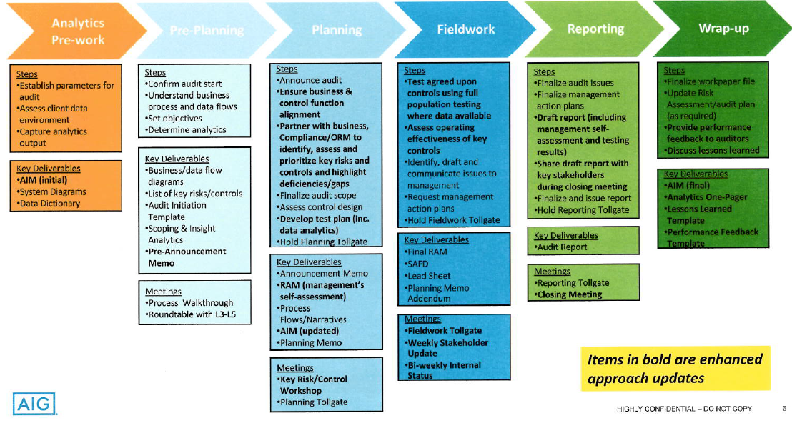

## AGILE AUDIT

Agile concepts: •Audit Increment planning” build a backlog of key risks and controls •Execute each sprint (2 week intervals) •After each sprint have a sprint review meeting with L4 to discuss results and initiate. After each sprint have tollgate to discuss stopping or continuing with audit •After each sprint and before next Sprint have Lessons learned session to discuss went well in sprint and what needs enhancements from next sprint •Holding daily scrum meetings (10 minutes) to discuss progress from yesterday, plan for current day and if any escalation is required

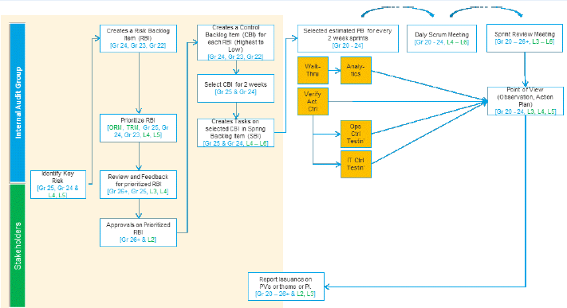

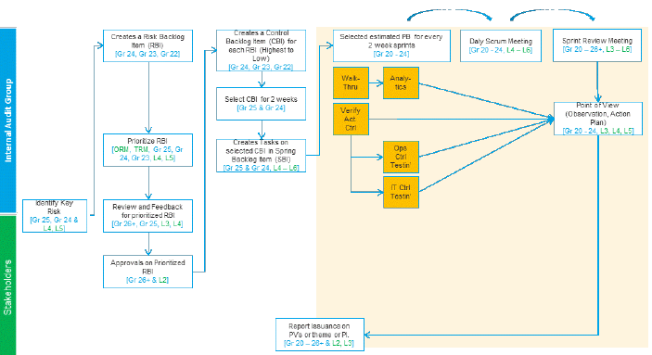

## APPLICATION DEVELOPMENT AGILE

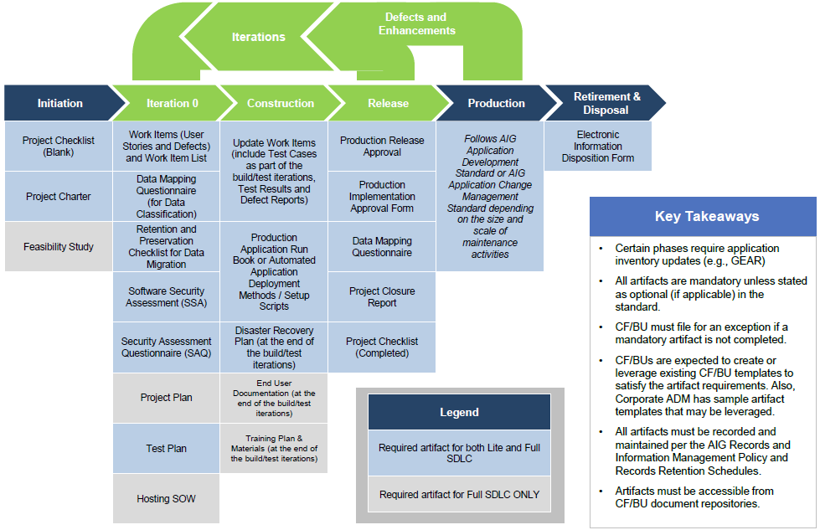

## NOVA Target State

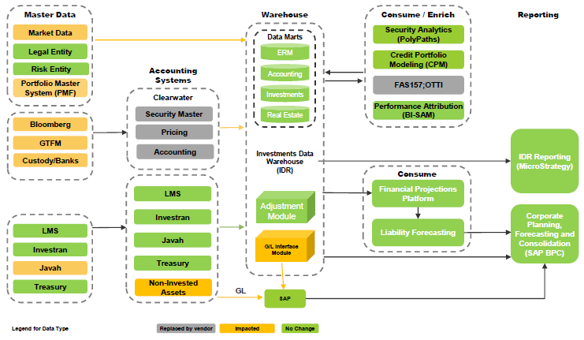

## IDR Data Governance

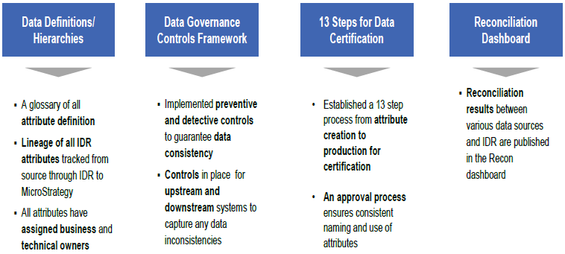

## IDR Data Quality Lifecycle

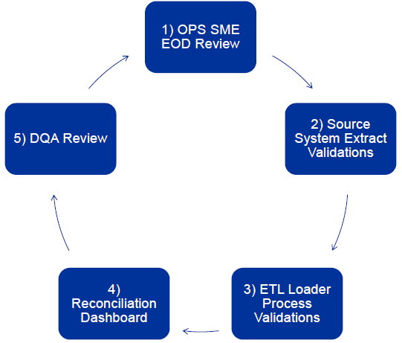

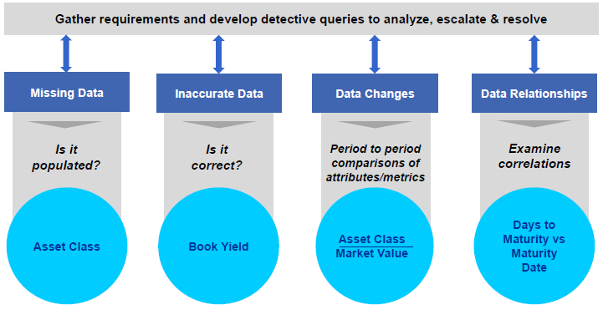

## IDR State Architecture

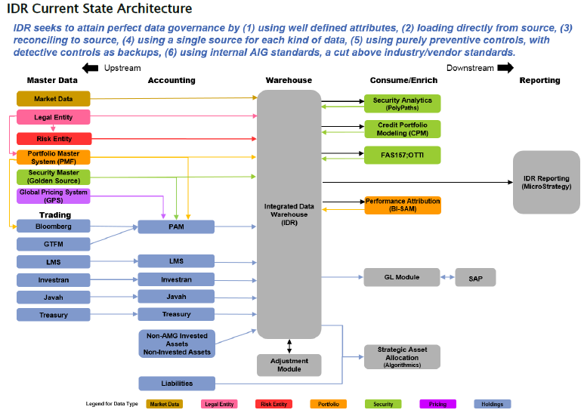

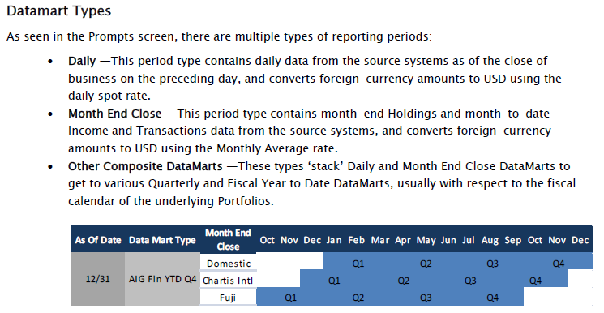

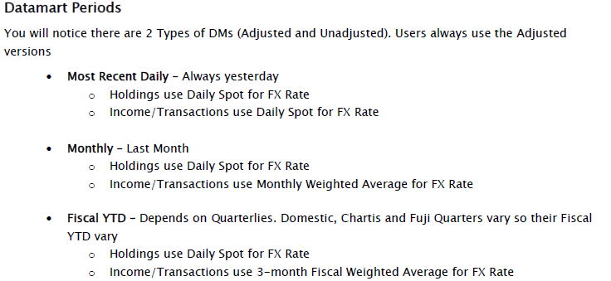

## NON-CLEARWATER

|  |  |  |  |  |
| --- | --- | --- | --- | --- |
| **\*IT Dependency Name** | **\*IT Dependency Type** | **\*Application 1** | **Associated Business Process(es)** | **FCU Contact** |
| Microstrategy - IDR Holdings Report OLD Microstrategy - IDR Holdings (TAX) Report NEW | Key Report | Microstrategy | Investment Accounting / Investment Operations / OTTI | Anthony/Jasmin |
| Level Change Report (2016) | Key Report | IDR | Financial Reporting (Leveling) | Cassie |
| Rule View Compare Report (2016) | Key Report | IDR | Financial Reporting (Leveling) | Cassie |
| Clearwater Multisource pricing file | Key Report | Clearwater | Clearwater | Cassie |
| Balance Sheet Queries / Price Exception Report | Key Report | IDR | Clearwater | Cassie |
| Private Placement Valuation PPV to Clearwater(CW) & Clearwater(CW) to PPV Interface Private Placement Valuation Yield to Price Calculation & Price to Yield Calculation | Key Interface | PPV/Clearwater | Clearwater | Cassie |
| Argus Quarterly Valuation Comparison Report (2016) | Key Report | Argus Enterprises | Global Real Estate (GRE) | Gene |
| GAAP Variance Analysis report | Key Report | BPC | Cap Corp | Gene |
| IDR Screening Report for Embedded Derivative Purchases (2016) | Key Report | Microstrategy | Fair Value Option | Gene |
| Interface SAP ECC to BPC | Interface | FW and SAP ECC | Cap Corp | Gene |
| Investran - Holdings Report (2016) | Key Report | Investran | Alternative Investments / Investment Accounting / OTTI | Gene |
| Investran Cash Activity Report (2016) | Key Report | Investran | Alternative Investments | Gene |
| Investran Valuations Report (2016) | Key Report | Investran | Alternative Investments | Gene |
| Javah to SAP Interface (2016) | Interface | Javah | Derivatives | Gene |
| LMS to IDR (2016) | Interface | LMS | CML | Gene |
| Microstrategy - Tax IDR Transactions Detail OLD Microstrategy - (GAAP/STAT) IDR Transactions Detail - **Purchases & Sales** | Key Report | Microstrategy | Alternative Investments / Investment Accounting | Gene |
| Microstrategy - IDR Transactions Detail Report - **Paydowns & Other Transactions** | Key Report | Microstrategy | Alternative Investments / Investment Accounting | Gene |
| R100 Validation Report (BPC TM1) (2016) | Key Report | BPC and IDR via TM1 | Investment Accounting | Gene |
| Schedules 46 & 60 Consolidated Report (2016) | Key Report | Javah | DAG | Gene |
| IDR DB Flow Report Daily | Key Report | IDR | Alternative Investments | Gene |
| IDR DB Flow Report Monthly | Key Report | IDR | Alternative Investments | Gene |
| IDR Income Earned (Tax Basis) Report OLD  Income Earned (GAAP/STAT) Report NEW | Key Report | Microstrategy | Investment Tax | Gene |
| Polypaths Cash Flow File / Securities of Interest List / FAS-91 | Key Report | IDR | Clearwater | Gene/Cassie |
| AIG Debt Repurchases Report (2016) | Key Report | JAVAH | Long-term debt | James |
| Autocheck GIC Draws/Deposits (2016) | Key Report | Autocheck | Derivatives | James |
| BizTalk to SWIFT | Interface | Biztalk | GCM Operations | James |
| Bloomberg to TSA Interface (2016) OLD Bloomberg to JAVAH Interface (2016) NEW | Interface | Bloomberg | AIGFP Investments / GCM Ops / Investment Operations | James |
| CA Change Report | Key Report | SEC Haircut | Derivatives | James |
| Cash Flow Oracle Schedules (2016) | Key Report | Oracle | AIGFP Financial Reporting/Intercompany | James |
| JAVAH to AutoCheck Interface | Interface | Javah | Derivatives | James |
| Javah to SACM (2016) | Interface | Javah | Multiple processes GCM Operations | James |
| JAVAH to TRS Interface (2016) | Interface | JAVAH | Derivatives | James |
| LMS Alter Due Audit Report (2016) | Key Report | LMS | CML | James |
| LMS Daily Cash Detail Report (2016) | Key Report | LMS | CML | James |
| LMS Loan Terms Audit Report (2016) | Key Report | LMS | CML | James |
| LMS Trial Balance Report (2016) | Key Report | LMS | CML | James |
| MAT (Manual Adjustment Table) Change Report | Key Report | SCA | Derivatives | James |
| Quick CA Report | Key Report | SEC Haircut | Derivatives | James |
| Rate Reset Report (2016) | Key Report | PROF | Derivatives | James |
| SACM to Biztalk | Interface | Biztalk | GCM Operations | James |
| SACM to DTDF (2016) | Interface | SACM | GCM Operations | James |
| SCA Daily Call Activity Report | Key Report | SCA | Derivatives | James |
| SSRS (SMF Change Report) | Key Report | JAVAH | Derivatives | James |
| Survelliance Report (2016) (renaming to watchlist report) | Key Report | LMS | CML | James |
| FAS 157 leveling to Clearwater (nightly Extract of Xnet ID, BAC, FAS157 and AIG derived rating from IDR datamart to CW) | Key Interface | IDR/Clearwater | Clearwater | James |
| Form B Transfer Trans Report (Asset Transfer Population Report) | Key Report | Clearwater | Clearwater | James |
| Asset Transfer Transaction Report | Key Report | Clearwater | Clearwater | James |
| Cross Trades Report | Key Report | Clearwater | Clearwater | James |
| Banks to OpenLink (SWIFT/Biztalk to Openlink) | Interface | OpenLink | Corporate Treasury | Jasmin |
| FNSCS Non-Statutory Inventory Report and LOC | Key Report |  |  | Jasmin |
| OL Make/Checker - Payee Setups | AAC | OpenLink | Corporate Treasury | Jasmin |
| OL SOD Wire - Enter/Modify/Release (2016) | AAC | OpenLink | Corporate Treasury | Jasmin |
| OLE Balancing Report | Key Report | OpenLink | Corporate Treasury | Jasmin |
| OLE Bank Transaction Report (2016 new) | Key Report | OLE | Corporate Treasury | Jasmin |
| OLE Daily Adjustments (Back Value) Report | Key Report | OLE | Corporate Treasury | Jasmin |
| OLE Remote Wire Upload Report | Key Report | OLE | Corporate Treasury | Jasmin |
| OpenLink maker/checker - Template Setups | AAC | OpenLink | Corporate Treasury | Jasmin |
| OpenLink to Biztalk | Interface | OpenLink | Corporate Treasury | Jasmin |
| SAP CD - OL | Interface | SAPCD | Corporate Treasury | Jasmin |
| OLE Remote Wire Status Report | Key Report | OpenLink | Corporate Treasury | Jasmin |
| Source systems to CDCS | Interface | CDCS | Corporate Treasury | Jasmin |
| Stat Security Change Report/LOC Statutory Inventory Report | Key Report | LOC | Corporate Treasury | Jasmin |
| WDS to OpenLink | Interface | WDS | Corporate Treasury | Jasmin |
| WDS to ORD/Trust | Interface | WDS | Corporate Treasury | Jasmin |
| Ariba is updated daily, via automatic feeds, with data from WDS. This includes changes in employment status  Any issues related  to the data feeds are addressed Ariba Systems and Operations in a timely basis. | Interface | WDS | Other General Operating Expenses | Jasmin |
| Fieldglass is updated daily, via automatic feeds, with data from WDS. This is an Auto Feed, Daily Load, which includes adding / removing users. In-coming feeds Auto-Monitored by Off-Shore – Shared Services Team and Accenture Team. | Interface | WDS | Other General Operating Expenses | Jasmin |
| SAP EP1 to Biztalk for wire payments | Interface | SAP Ep1 | AP (Other General Operating Expenses) and Treasury | Jasmin |
| Same individual is unable to both setup and release purchase order | AAC | Ariba | Other General Operating Expenses | Jasmin |
| Approver limits are checked by the system. | AAC | Ariba | Other General Operating Expenses | Jasmin |
| Fiscal authority limits is automatically updated in Fieldglass from WDS | AAC | Fieldglass | Other General Operating Expenses | Jasmin |
| Requisition/Work Order is automatically routed to the appropriate individuals for approval based on fiscal limits, and the SOW is created based on the approved terms and amounts. | AAC | Fieldglass | Other General Operating Expenses | Jasmin |
| SAP is configured to perform a three way match between the Purchase Order, Invoice, and Receiving Documents.  SAP is set up to reject Invoices (block the payment) if an item does not match. | AAC | SAP AP | Other General Operating Expenses | Jasmin |
| Invoices submitted on an SOW that cause the total amount paid on the SOW to exceed the total amount approved for the SOW are rejected by Fieldglass and will not be sent for payment. | AAC | Fieldglass | Other General Operating Expenses | Jasmin |
| When invoices are created in SAP VIMS, automated controls ensure that key mandatory fields (e.g., vendor, bank, company code, invoice reference field) are populated and then these key mandatory fields are validated against the Master SAP Data. | AAC | SAP AP | Other General Operating Expenses | Jasmin |
| System prevents the Payment Proposer and Payment Executor from modifying the payee and amount on any invoice.  Payment method and paying bank account can be changed. | AAC | SAP AP | Other General Operating Expenses | Jasmin |
| Once the vendor master data is approved upon data entry, systematic validation is performed to identify any errors on the specific fields on the vendor information.  The request cannot be saved until all mandatory fields by account group are entered.  Any errors identified are manually re-routed to the appropriate party for resolution. | AAC | Vendor Master (SAP) | Other General Operating Expenses | Jasmin |
| Any attempt to create or modify sensitive fields automatically results in a temporary vendor payment block and sensitive reviewer must approve the sensitive fields to unblock. System automatically prevents the same ID from Vendor Master Data Maintainer and the Sensitive Field Approver to confirm. Sensitive data is masked to avoid violation of Privacy Laws. | AAC | Vendor Master (SAP) | Other General Operating Expenses | Jasmin |
| COA change report | Key Report | SAP EP1/DOA (WDS) | Other General Operating Expenses | Jasmin |
| SE16N (report_LFA1) | Key Report | SAP EP1 | Other General Operating Expenses | Jasmin |
| SAP- CD to Biztalk | Key Report | SAP - CD | Treasury | Jasmin |
| Appian - SOD Wire Enter/Modify/Release | AAC | Appian-Wire | Corporate Treasury | Jasmin |
| Appian to OpenLink Interface | Interface | Appian-Wire | Corporate Treasury | Jasmin |
| ACH 824 Acknowledgement Reconciliation Report | Key Report | CDCS | Corporate Treasury | Jasmin/Allen |
| ACH 997 Acknowledgement Reconciliation Report | Key Report | CDCS | Corporate Treasury | Jasmin/Allen |
| CDCS Automated Balancing - Automated balancing routines are in place to ensure that transmitted files to CDCS are accurate and complete. (Source systems to CDCS). | AAC | CDCS | Corporate Treasury | Jasmin/Allen |
| CDCS Interface Balance Report (CDCS auto balancing routine reports)(CDCS to Emdeon) | Key Report | CDCS | Corporate Treasury | Jasmin/Allen |
| IDR to Revport Interface | Interface | Revport | AMG US |  |

## CLEARWATER

|  |  |  |  |  |  |  |  |
| --- | --- | --- | --- | --- | --- | --- | --- |
| **Control Name** | **Report Name** | **Description of Nature/Usage** | **Input Source  (i.e. system feeding this report)** | **Describe How Report is Generated(i.e. Microstrategy, Canned Report, Query, etc.)** | **RA Comments** | | |
| Reconcile consolidated price exception report to validation results | Clearwater Multisource pricing file | File contains alternate prices for the bonds and equity portfolio for any given as-of date. This is used as an input to the Excel EUC (Exception Generation tool) as well as for the stored procedures. | Clearwater | CW sent through SFTP or IVFA Downloaded from the Clearwater Portal | In Scope | | |
| Private Placements | Amortization schedules from Clearwater for WAL calculation | (Anthony Versaci) File received from Clearwater for Amortization schedules. This file is sent via SFTP and Analytics IT has a process to copy from IT into our production folder for load into Oracle. | Clearwater | CW sent through SFTP and and Analytics IT has a process to copy from IT into our production folder for load into Oracle. | AL Comparison Report for Q1. Different amortzation schedules are used by investment analytics to recalculate a WAL then the AL comparison report compares mgmt's WAL, vs investment analytics WAL and also shows the change quarter over quarter in WAL. | | |
| Reconcile consolidated price exception report to validation results | Balance Sheet Queries /  / Price Exception Report | Report run out of Microstrategy to obtain MVs of the full population of securities that make up the fair valued bond and equity balance sheet line items of AIG's GAAP consolidated balance sheet. | IDR | Microstrategy | In Scope | | |
| The "Securities of Interest List" key report that existed pre-CW is no longer used | Polypaths Cash Flow File / Securities of Interest List / FAS-91 | The investment analytics team now uses a cash flow file from Polypaths. Stephen DeTommaso and Anthony Versaci are the contacts. | IDR | Microstrategy | In Scope | | |
| Review Asset Transfer reconciliation | Form B Transfer Trans Report (Asset Transfer Population Report) | Report run from the Clearwater website to show all asset transfers processed during a specified time period. | Clearwater | Run from the Clearwater website | In Scope | | |
| Review Asset Transfer reconciliation | Asset Transfer Transaction Report | Used to ensure that all asset transfers are executed at Clearwater | Clearwater | Run from the Clearwater website | In Scope | | |
| Review report identifying cross trades | Cross Trades Report | To identify buy/sell trades entered by the front office that should have been booked as interportfolio transfers. | Clearwater | Run from the Clearwater website | In Scope | | |
| Review and approve Price Override Report | Price Override Report | Clearwater process treats manually instructed prices as overrides. Dublin Operations is planning to generate and periodically review the Clearwater override report.  As of 11/9 Reliance on Clearwater for complete and accurate recording of manual prices | Clearwater | Run from the Clearwater website | Per FCU, the report is not used by the business. Confirmed with Core | | |
| Identifies updated SMF records in which the tax fields are updated based on instructions from ITG. | Clearwater New Positions Report | Appian Confirmations Report (Appian to ITG Tax Class Reconciliation) No longer used. Investments Tax Group (ITG) will periodically download a CW new positions report and review the new SMF tax attributes | Clearwater | Run from the Clearwater website | Per FCU, the report is not used by the business. Confirmed with Core | | |
| Approve transactions entered in Bloomberg by NY Front Office | Trade Blotter Report from CW | PM's review and approval of trades listed on the blotter. | Clearwater | TSA/Dart Custom Report | Testing Blotter - Structured NY - Year to Date - IA | | |
| Review and approve JAVAH transaction trade blotters | Trade blotter from Javah | To identify and evidence approval of all trades that occur on a given day. | JAVAH | Canned Report | No testing required | | |
| Resolve exceptions for DQA reports | Data quality exception reports | Used to verify data quality of Microstrategy reports | Javah, LMS, CW, Investran | For the sub-ledger feed Clearwater will replace PAM | Meeting Requested | | |
| Review and sign off on final OTTI details for equity securities population | PAM report of equity securities in an unrealized loss position | Used to assess securities for write downs | Clearwater | Feed from CW | Per FCU, the report is not used by the business. Confirmed with Core | | |
| Validate completeness of OTTI population | OTTI Module Rule-Set Report (OTTI Evaluation Portfolio Listing) (i.e. Listing of in-scope portfolios)) | Used to determine the in-scope population for OTTI | Microstrategy | Feed from CW | Per FCU, the report is not used by the business. Confirmed with Core | | |
| Review RML cash reconciliation | Clearwater Cash Rec Report (RML) | Identifies reconciling items resulting from the RML Cash reconciliation performed by Clearwater. | Clearwater | Downloaded from the Clearwater Portal | Confirmed with RML, Non-Key | | |
| Review RML Trial Balance Reconciliation | Clearwater GAAP Base Balance Sheet by Lot Report (RML Holdings Report) | Used as an input for the RML outstanding principal balance reconciliation. | Clearwater | Downloaded from the Clearwater Portal | Confirmed with RML, Non-Key | | |
| Review and approve changes to FAS 157 leveling rules | FAS 157 leveling to Clearwater (nightly Extract of Xnet ID, BAC, FAS157 and AIG derived rating from IDR datamart to CW) | IDR to CW | Clearwater | Global Operations - Dublin Operations | Real feed or extract sent via email? We test 2 reports here Level Change Report & Rule View Compare Report.  TEST: Rule View Compare Report | | |
| Review and approve Private Placement valuation | Calculated prices or yields from Clearwater back to PPV | CW to PPV | Clearwater | AIGI Front Office - Private Placements | Peter - Completeness + Calcs | | |
| Review and approve JAVAH transaction trade blotters | Trade details of trades executed on Bloomberg to Javah | BBG to JAVAH | Clearwater | AIGI Front Office - GCM | Non-Key. Removed. FCU tests Recs | | |
| Review and approve Private Placement valuation | Prices or yields from PPV including calculation + PPV to Clearwater, Clearwater to PPV (yield to price) | PPV to CW, CW to PPV | Clearwater | Price calculation for private placement securities will be performed in Clearwater. The PPV data is sent to and received from Clearwater via web service connection. | Peter - Completeness + Calcs | | |
| Review Asset Transfer reconciliation | Report from PAM Direct detailing the transfers | Used to ensure that all asset transfers are executed in PAM | Clearwater | Downloaded from the Clearwater Portal |  | | |
| Review and approve asset reconciliations | Reconciling Items Aging Reports | To age reconciling items. | Clearwater | Oversight control to be implemented by Dublin Investment Ops for review and monitoring of aging items.  Per Dublin Investment Ops, the report is not yet available as of 10/24/18. | |  | |
| Review and approve cash reconciliations | Reconciling Items Ageing Reports | To age reconciling items. | Clearwater | Oversight control to be implemented by Dublin Investment Ops for review and monitoring of aging items. Per Dublin Investment Ops, the report is not yet available as of 10/24/18. | | |  | |
| Income analyzer (is this used as a monitoring control?) | | |  | Non-Key |  | | |
| Monitoring of aging of reconciliation aging (what additional controls is management planning to perform with this report?) | | |  |  |  | | |